Logging in to the Reseller Box Office
All users access the same Reseller Box Office URL that opens the Login page, and all users are required to log on to the Reseller Box Office. The Login page requires a user name and password.
The login page is located at the following web address:
http://tickets.sandiegozoo.org/Reseller/Account/login.aspx
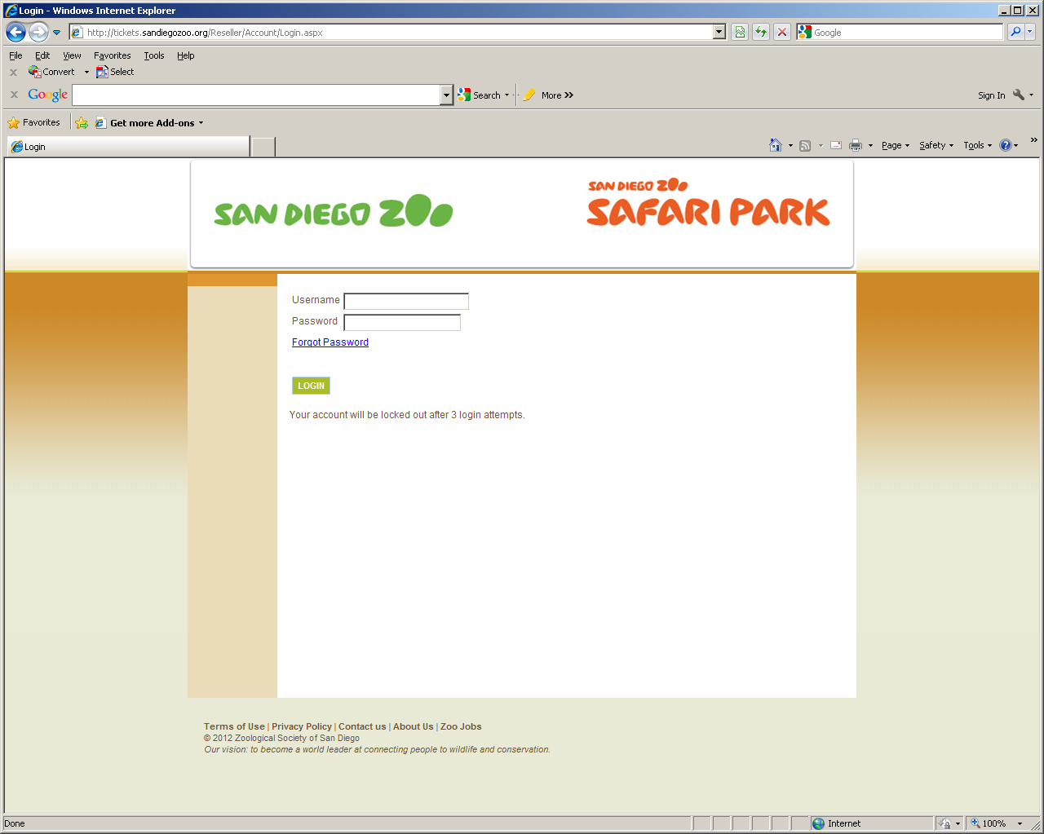
When you log on to the Reseller Box Office, one of the following occurs:
- If a user name is not found or it is an inactive user name, the logon fails.
- If you are not successful logging on after a number of attempts, the logon fails. You are prompted to contact your Outside Sales Manager.
- If you log on successfully but your password is set to expire, the Reset Password page opens. From this page, you must enter your old password, create a new password and confirm the new password. You are then prompted to confirm an existing security question and select a new security question.
- If you forget your password, selecting the Forgot Password link opens a security question page.
- When you successfully log on, the store links are available

To log on to the Reseller Box Office:
- On the Login page in the Username field, type your username.
- In the Password field, type your password.
- If you forgot your password, select the Forgot Password link.
- Select Logon.

Selecting Your Store and Location
When you log on to the Reseller Box Office for the first time, you are forced to select your location. This action tracks transactions in the exact locations from which they occur. When you log on again, the location defaults to what you choose now.

- To select your store and location:
- Use the Select Store arrow to select your store.
- Use the Select Location arrow to select your present location within the store.

Understanding Security Questions
The first time you log on to the Reseller Box Office, the security question page prompts you to select a question and answer it. This security question is also used when you change your password or forget your password. If you select the Forgot Password link on the log on page, the security question page opens. You must answer the security question correctly to log on to the Reseller Box Office.
On the security question page, the Username field displays your user name. The Security Question field displays the question that you selected when logging on to the Reseller Box Office for the first time, or when you changed your password.

Changing Your Password
When you log on to the Reseller Box Office for the first time, you are prompted to change the password sent to you by your Reseller Box Office Admin. You may be required to change your password at set time intervals. You may also be required to use strong passwords, which are passwords of a certain character length, or those containing special characters or numbers.
To change your password:
- In the Old Password field, type your old password.
- In the New Password field, type your new password. (Note: your password must be 8-10 digits long and contain one Capital letter and one number.
- In the Confirm Password field, retype your new password.
- Select OK.
Selling Tickets
When your resellers work with tickets on the Reseller Box Office, they can sell and print tickets at their stores, as well as process returns.
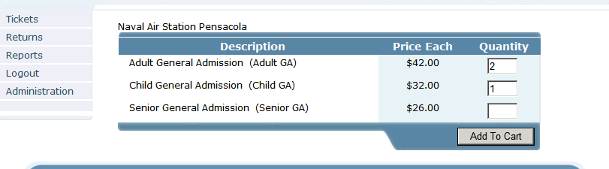

To sell tickets on the Reseller Box Office:
On the Tickets page in the Quantity field, type the number of tickets to add to the order, then select Add To Cart. The Review page opens.
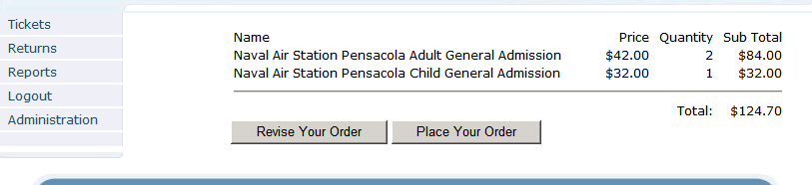
On the Review page, do one of the following:
- To make changes to the order, select Revise Your Order. The Tickets page reopens for your changes.
or
- To accept and place the order, select Place Your Order. The Confirmation page opens.
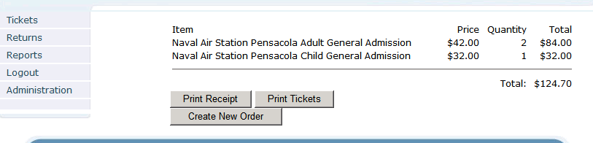
On the Confirmation page, do one or more of the following:
- To print a receipt, select Print Receipt.
- To print the tickets, select Print Tickets.
- To create a new order, select Create New Order. The tickets page reopens.

Returning Tickets
When you return a ticket on the Reseller Box Office, you must supply the Visual I.D. / Barcode for the ticket.
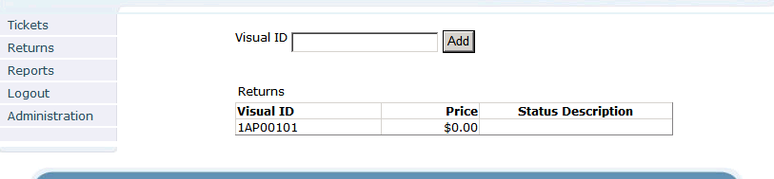
If you do not have the ticket present and need the Visual I.D. to return the ticket, you can obtain the Visual I.D. by running a Detail Report.
Note: When you enter the Visual I.D., there will be a green check mark when the ticket is valid. If the ticket has been used or returned, the status of the ticket will be displayed at that time.

To return a ticket:
On the Tickets page in the Visual ID field,
- Type the visual ID for the ticket.
- Click Add
- Click Return
A return receipt will generate. (Note: Receipt is not designed for customer use but for internal reconcile documentation).

Logging Off of the Reseller Box Office
When you select Logout from any page on the Reseller Box Office, the system ends the session and displays the Login page.
To log off the Reseller Box Office:
- From the navigation area, select Log Out.

