San Diego Zoo and Safari Park 1-Day Ticket Reservations in Reseller Box Office (RBO)
NOTE: RBO no longer allows issue of more than total tickets within a single party purchase. Reservation date selection required.

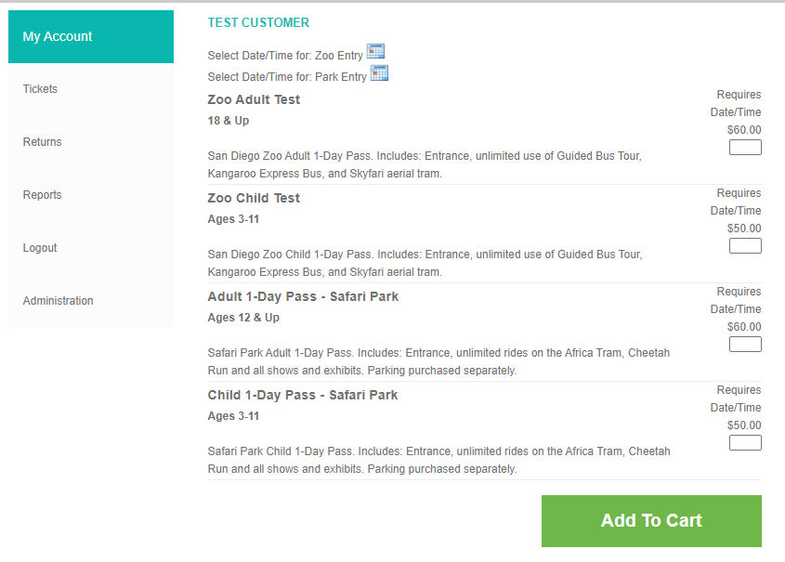
- Click on the applicable event calendar (Red Arrow)
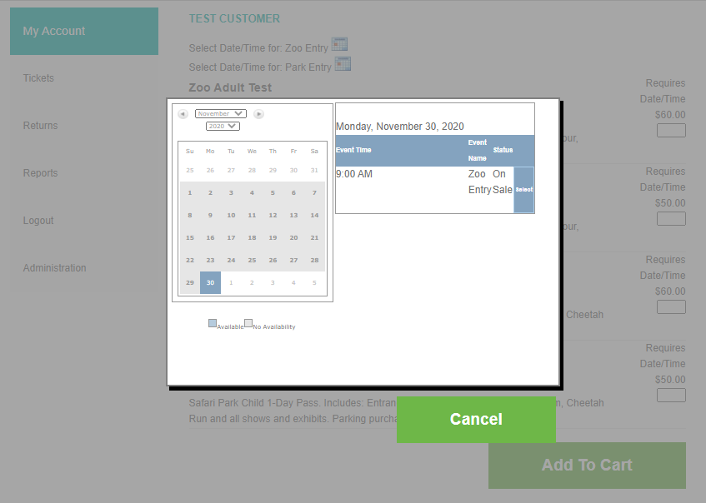
- The calendar defaults to the first available day. If the current day date is not available, the next applicable date will be displayed. Calendar dates highlighted in blue are available. The calendar will only show availability one month at a time.
- Choose the desired date. For this example, we are picking November 30.
- Verify the date chosen on the calendar matches the date available. Click the “Select” button for the desired date.
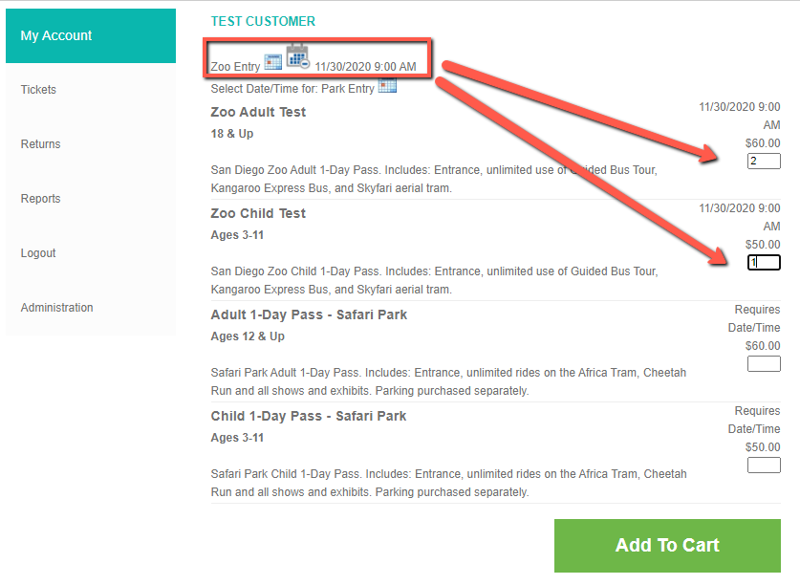
- Enter the applicable number of Adults and Children for the location (Red Arrows)
- Confirm the details and Verify the date for each PLU matches the desired date chosen
- (Circled)
- Repeat process for any additional dates
- Scroll to the bottom of the screen and click “Add to Cart” (Green Arrow)
*If you need to change the date, click on the calendar icon again and repeat the process

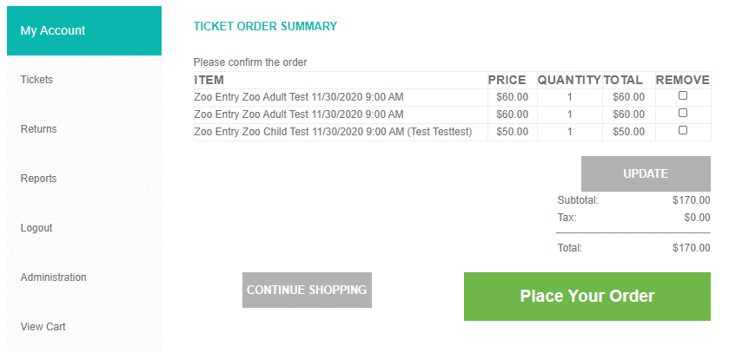
- Verify date and ticket types (Red Arrow)
- Click “Place your order” (Green Arrow)
- Please print the PDF ticket that generates and provide to your guest. They will need to present it at the turnstyle. PDFs can be printed or show on a mobile device with PDF reader capabilities.

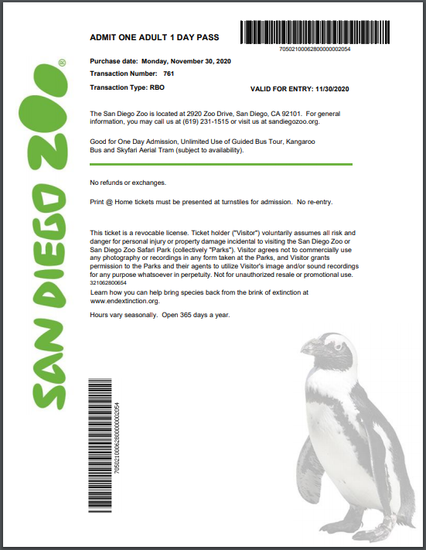

- The Reservation Date will now be shown as “Valid For Entry” (Circled)

