Reseller Box Office Table of Contents

- Accessing Reseller Box Office
        - Logging In p. 1
        - Selecting Store Location p. 3
        - Security Questions p. 4
        - Passwords p. 4
- Administrative Functions
        - Creating a Store Location p. 7
        - Creating Users p. 11
        - Locking / Unlocking a User p. 14
        - Update Ticket Pricing p. 15
        - Reports p. 22

- Ticketing Functions
        - Selling Tickets p. 18
        - Returning Tickets p. 20
- Pre-Paid Accounts
        - Checking a balance p. 29
        - Adding Funds to your account p. 32
- Internet Security
        - IP Address protection p. 34
- Sample Ticket p. 35

Logging in to the Reseller Box Office
All users access the same Reseller Box Office URL that opens the Login page, and all users are required to log on to the Reseller Box Office. The Login page requires an individual user name and password.
The login page is located at the following web address:
http://tickets.sandiegozoo.org/Reseller/Account/login.aspx
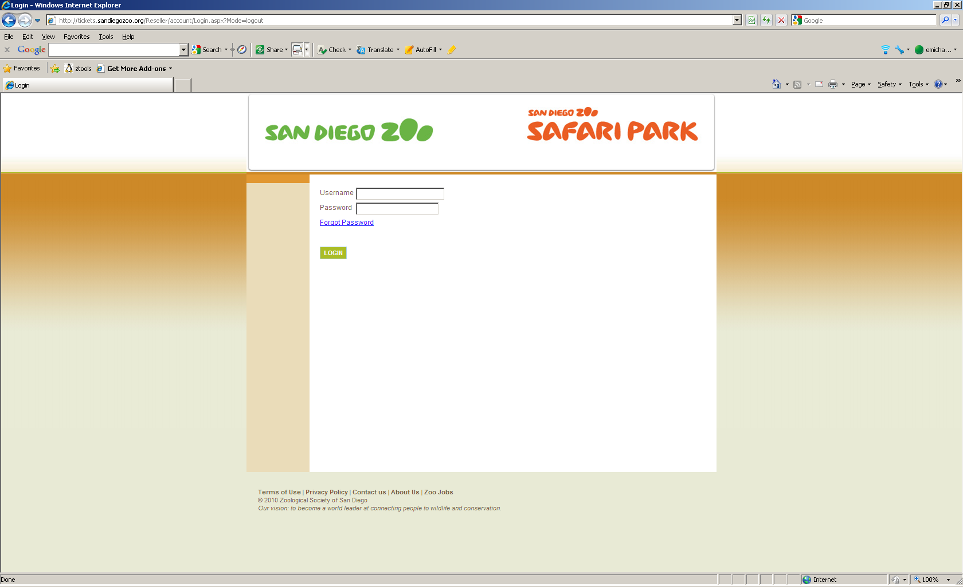
When you log on to the Reseller Box Office, one of the following occurs:
- If a user name is not found or it is an inactive user name, the logon fails.
- If you are not successful logging on after three of attempts, the logon fails. You are prompted to contact your Outside Sales Manager.
- If you log on successfully but your password is set to expire, the Reset Password page opens. From this page, you must enter your old password, create a new password and confirm the new password. You are then prompted to confirm an existing security question and select a new security question.
- If you forget your password, selecting the Forgot Password link opens a security question page.
- When you successfully log on, the store links are available

To log on to the Reseller Box Office:
- On the Login page in the Username field, type your username.
- In the Password field, type your password.
- If you forgot your password, select the Forgot Password link.
- Select Logon

Selecting Your Store and Location
When you log on to the Reseller Box Office for the first time, you are forced to select your location. This action tracks transactions in the exact locations from which they occur. When you log on again, the location defaults to what you choose now.


- To select your store and location:
- Use the Select Store arrow to select your store.
- Use the Select Location arrow to select your present location within the store.

Understanding Security Questions
The first time you log on to the Reseller Box Office, the security question page prompts you to select a question and answer it. This security question is also used when you change your password or forget your password. If you select the Forgot Password link on the log on page, the security question page opens. You must answer the security question correctly to log on to the Reseller Box Office.
On the security question page, the Username field displays your user name. The Security Question field displays the question that you selected when logging on to the Reseller Box Office for the first time, or when you changed your password.


Changing Your Password
When you log on to the Reseller Box Office for the first time, you are prompted to change the password sent to you by your Reseller Box Office Admin. You may be required to change your password at set time intervals. You may also be required to use strong passwords, which are passwords of a certain character length, or those containing special characters or numbers.

To change your password:
- In the Old Password field, type your old password.
- In the New Password field, type your new password. (Note: your password must be 8-10 digits long and include 1 number and one capital letter)
- In the Confirm Password field, retype your new password.
- Select OK.

Reseller Box Office Logged In
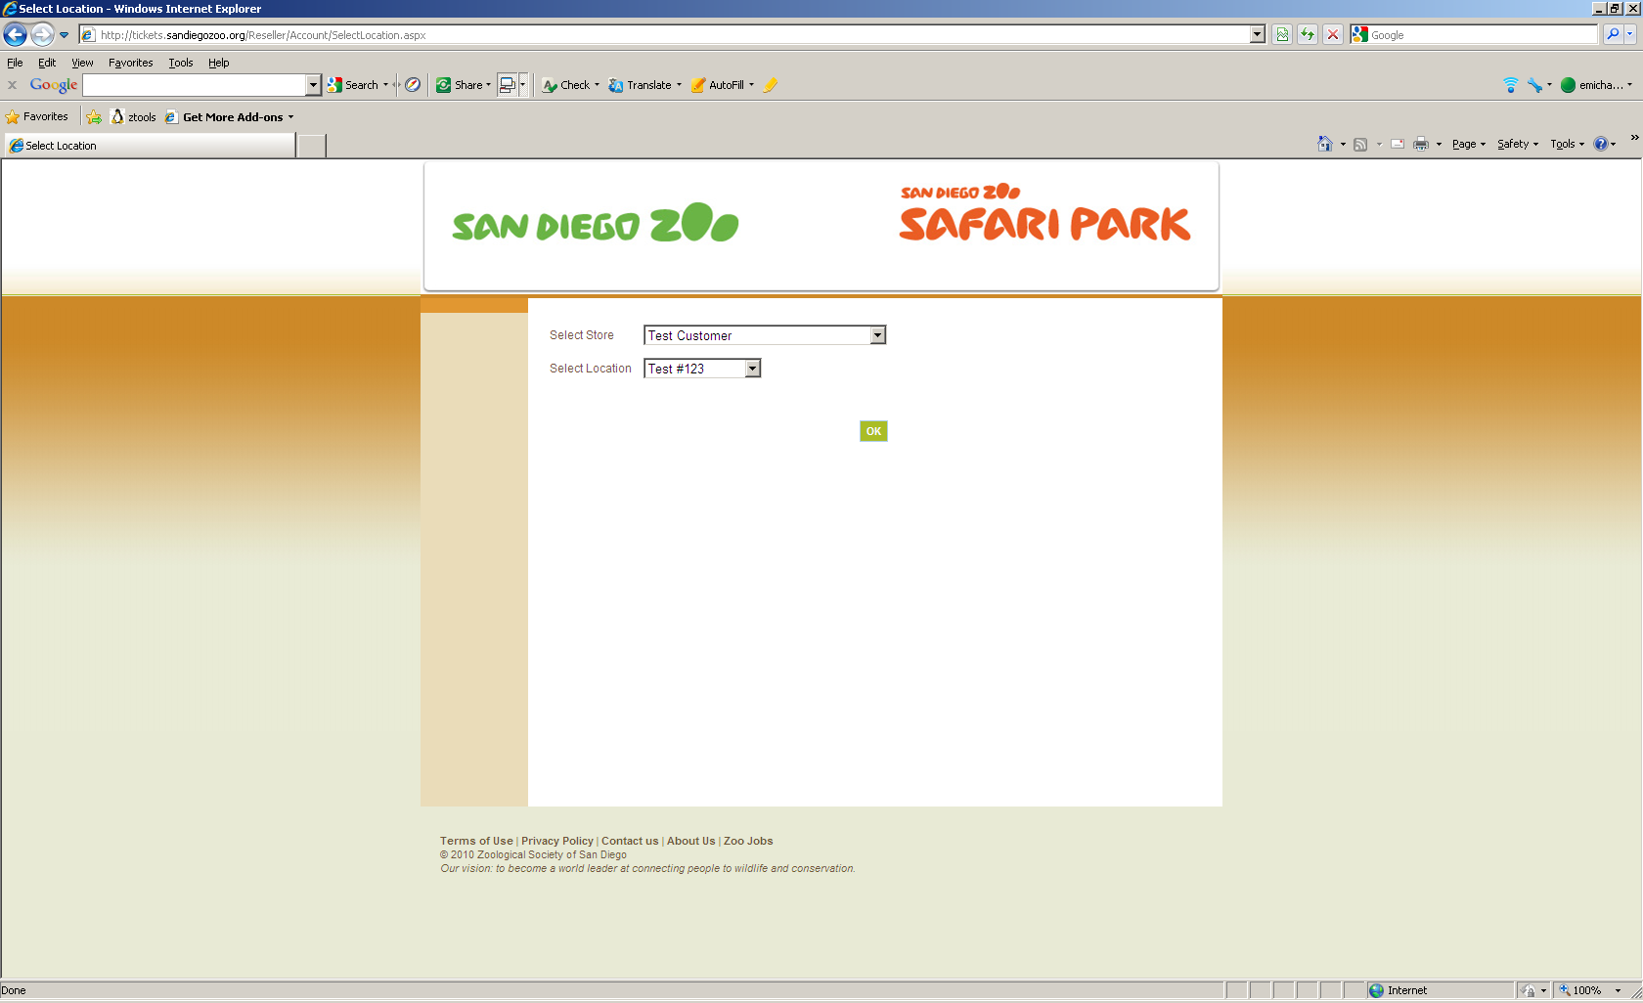

Your Company Name will show as the Store Name on the login Screen. The Location will default to Main Office (You may create multiple locations in the steps to follow).
- Click OK

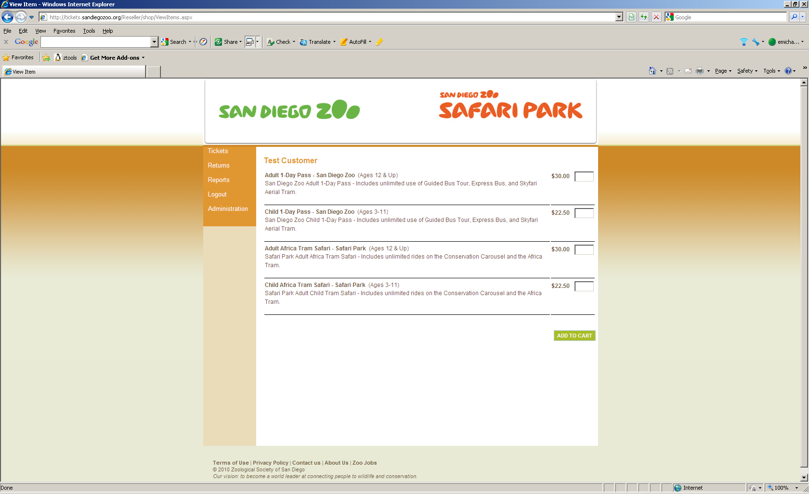

Reseller Box Office will display your Ticket Seller main page. The toolbar on the left side contains the the following options:
- Tickets – Ticket selection and sales page
- Returns – Ticket returns
- Reports* – reports of tickets sold, tickets returned and a summary report
- Logout – signing out the user
- Administration* – Create Locations, Create Users, Password reset, Ticket rate changes
* requires administrative privileges
Note: If your ticket page is blank, please refer to the table of contents, Section 2d

To set up your initial store or to make changes Click Administration
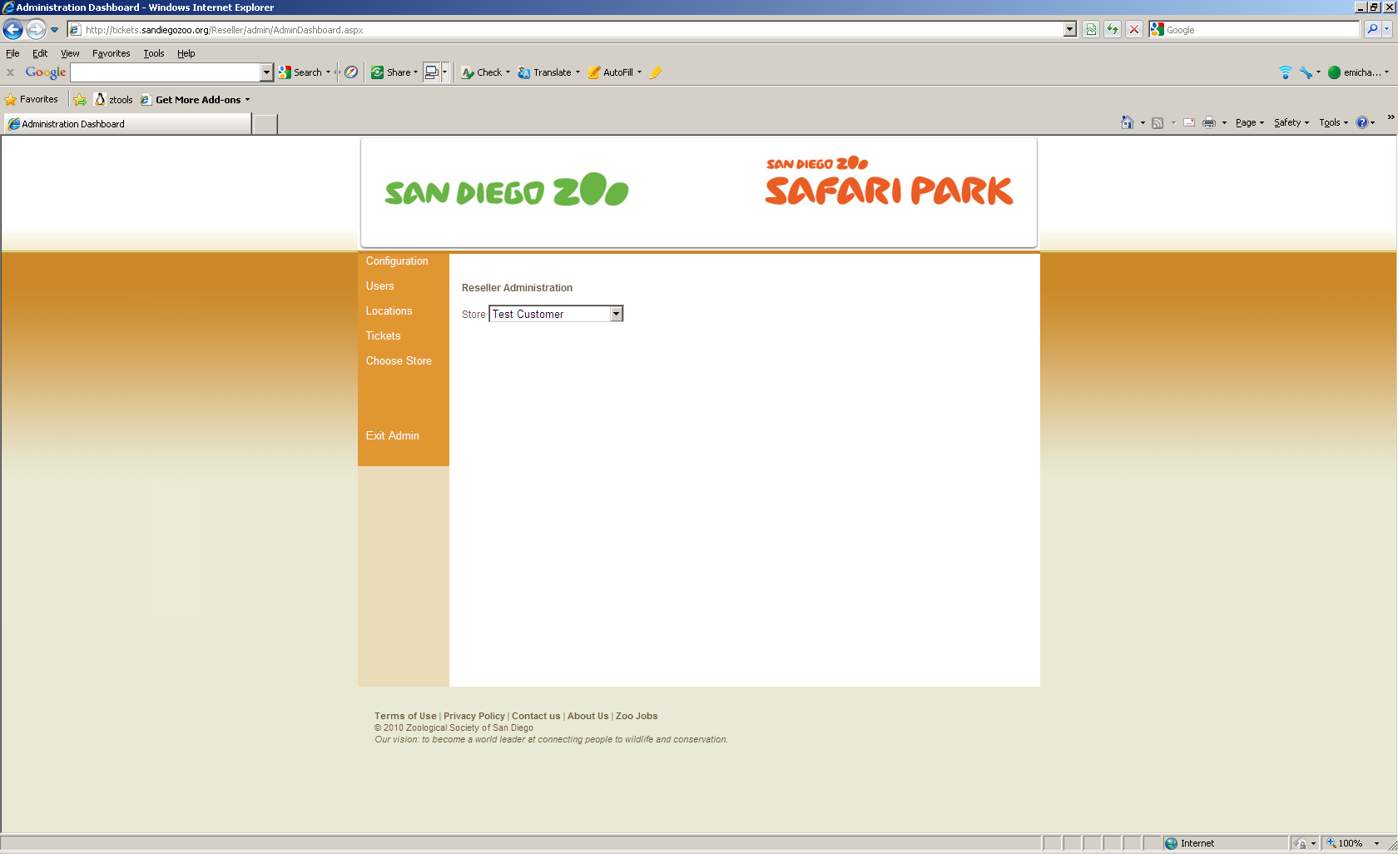
Creating Locations
If you are selling tickets at multiple locations and wish to designate them individually, you can create these in Reseller Box Office.
- Click Locations

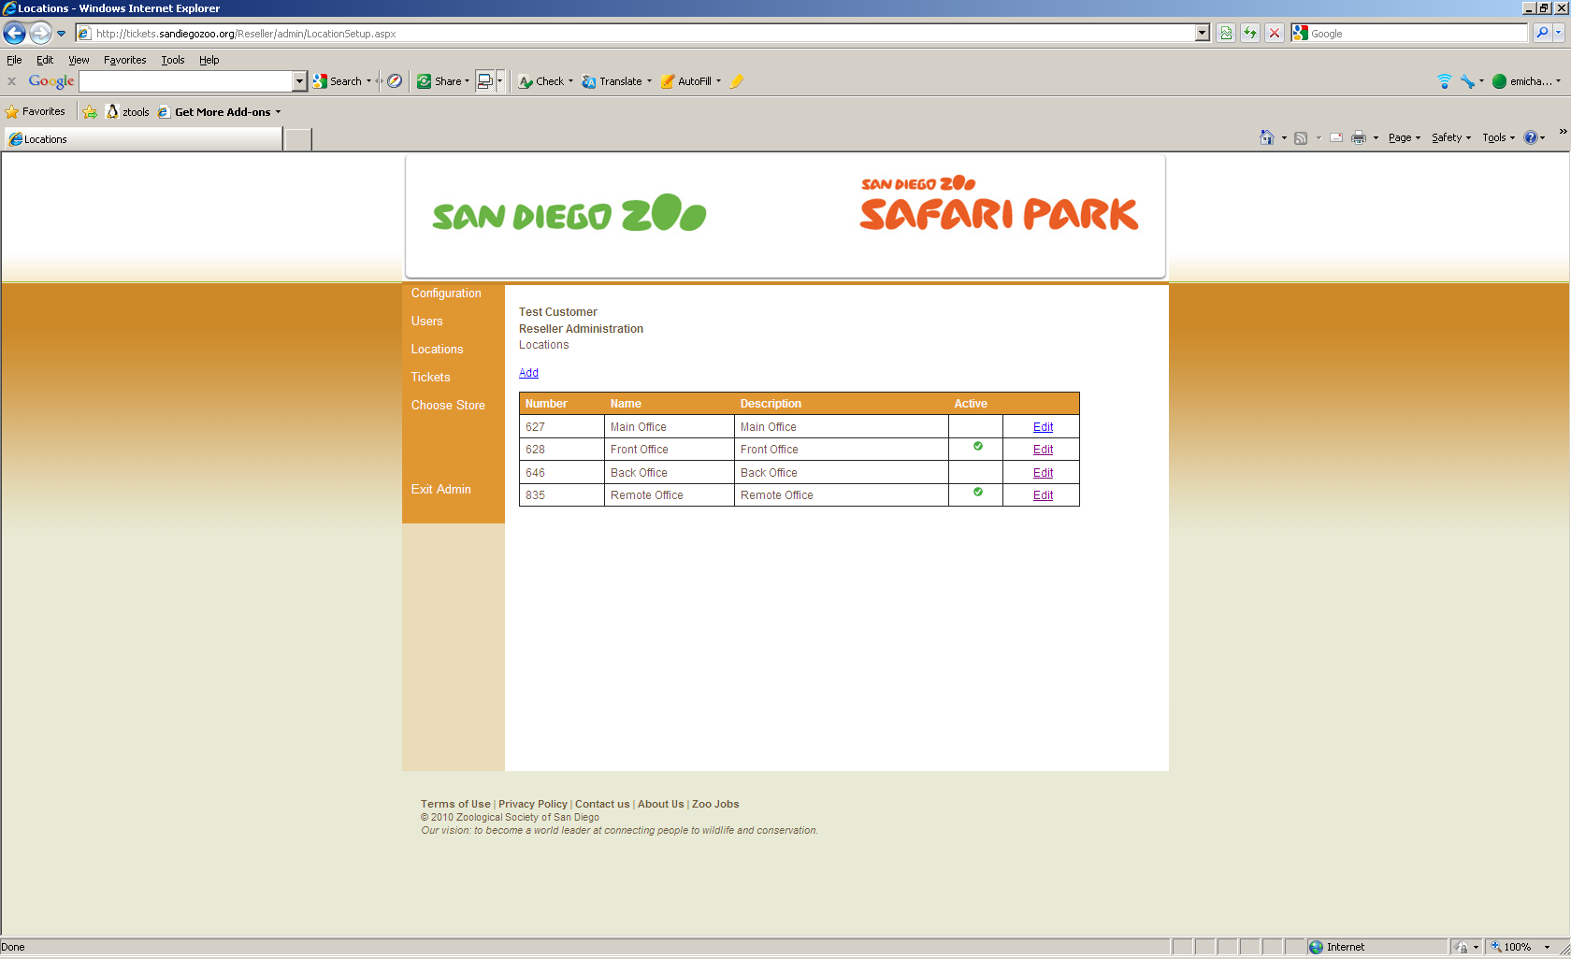
The Location page displays the following:
- Number – auto created by our Galaxy database sequentially
- Name – Name of the office
- Description – Allows more details for this location
- Active – Shows if office is active. A great option for seasonal offices to ensure no user select them in error
You may add locations or edit their information at any time.

To Add:
- Click Add

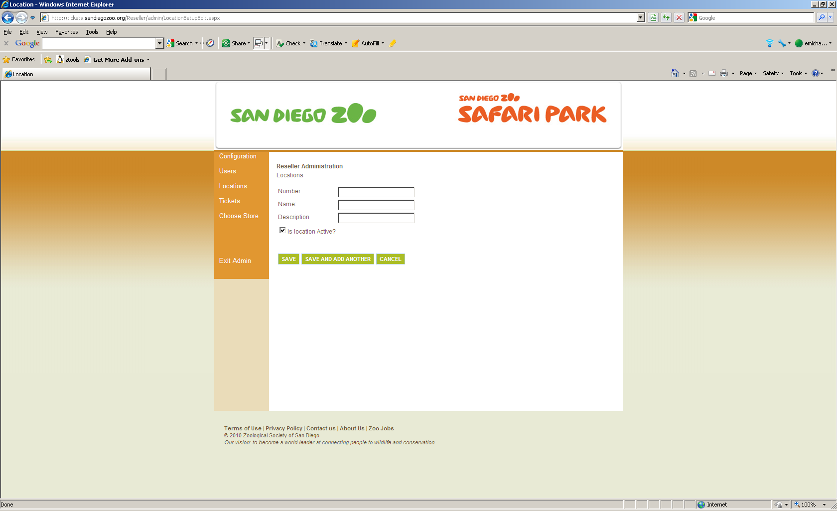
(Note: The number is not a user defined field and will be assigned by the software)
Enter:
- Name – Short name for new Location. This name will appear on reports
- Description – Allows for more detailed information to identify the new Location if desired however does not appear upon reports

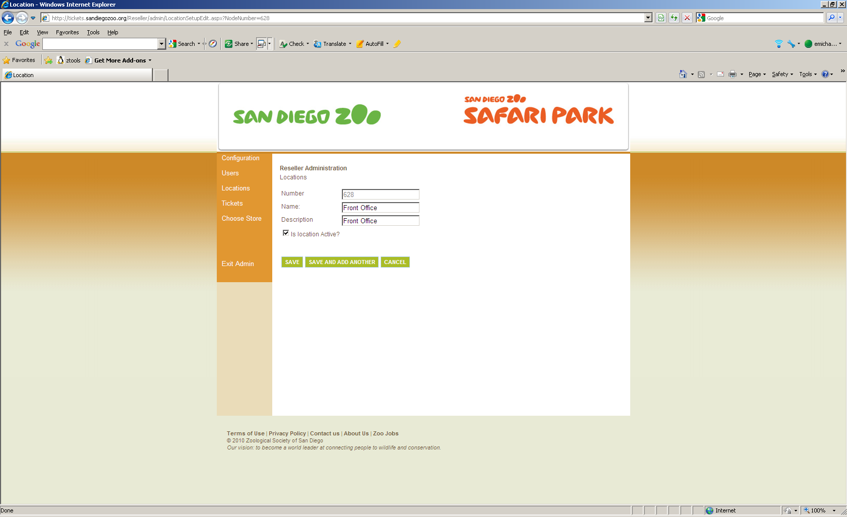
If you are creating multiple Locations, click Save and Add Another. If creating only one Location, click Save.

Reseller Box Office displays the number of Locations currently configured. The Administrator can edit the existing Locations or create new ones as necessary. Locations cannot be deleted.

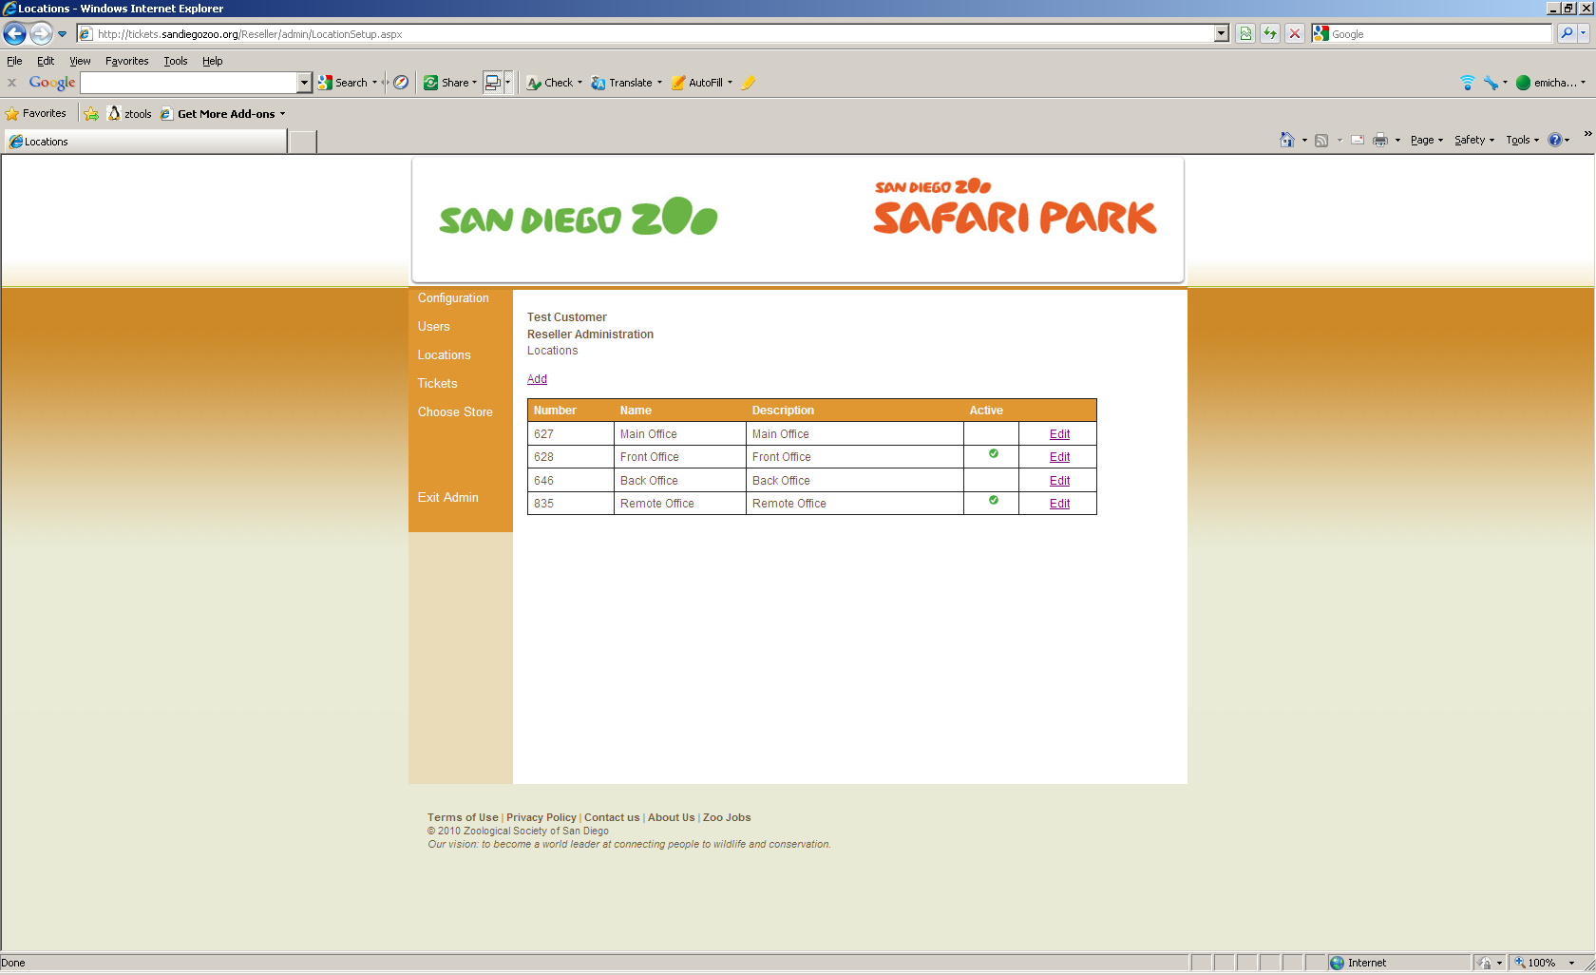
Creating Users
Reseller Box Office requires an individual user name for each Ticket Seller and Administrator. To Create Users:
- Click on Users.

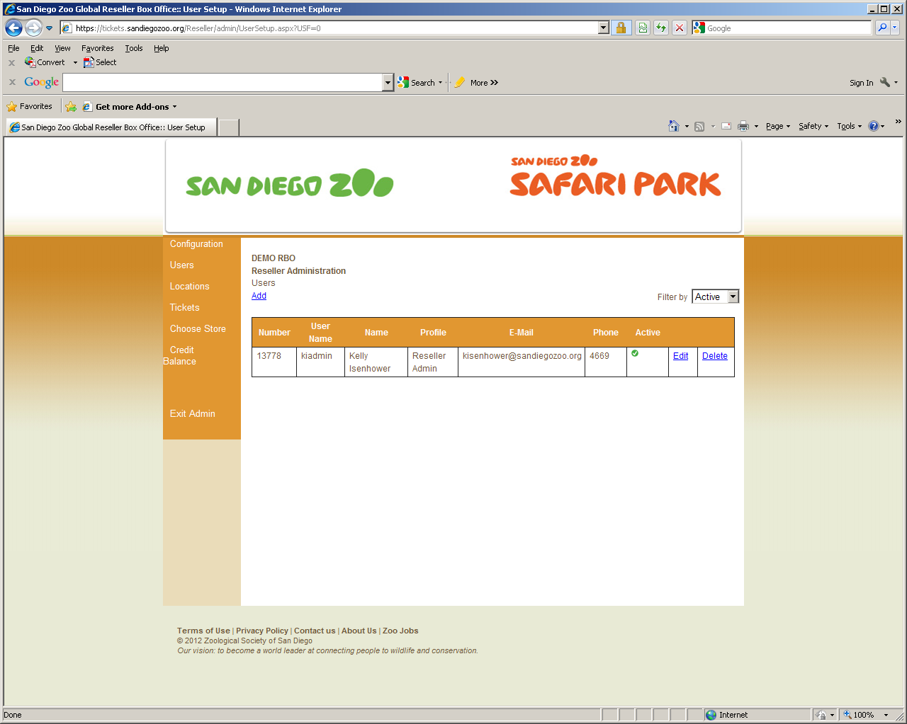
(Note: for historical and reporting purposes it is recommended to never delete a user. Options for locking out a user are available)

Reseller Box Office allows for five User types:
- Reseller Lead – those with administrative, report and ticket selling privileges
- Reseller Reports - those with report and ticket selling privileges
- Reseller Tickets - front line ticket sellers with ticket return privileges
- Reseller Tickets 2 - front line ticket sellers without ticket return privileges
- Reseller Manage User – those with user profile administrative privileges only

To Add:
- Click Add

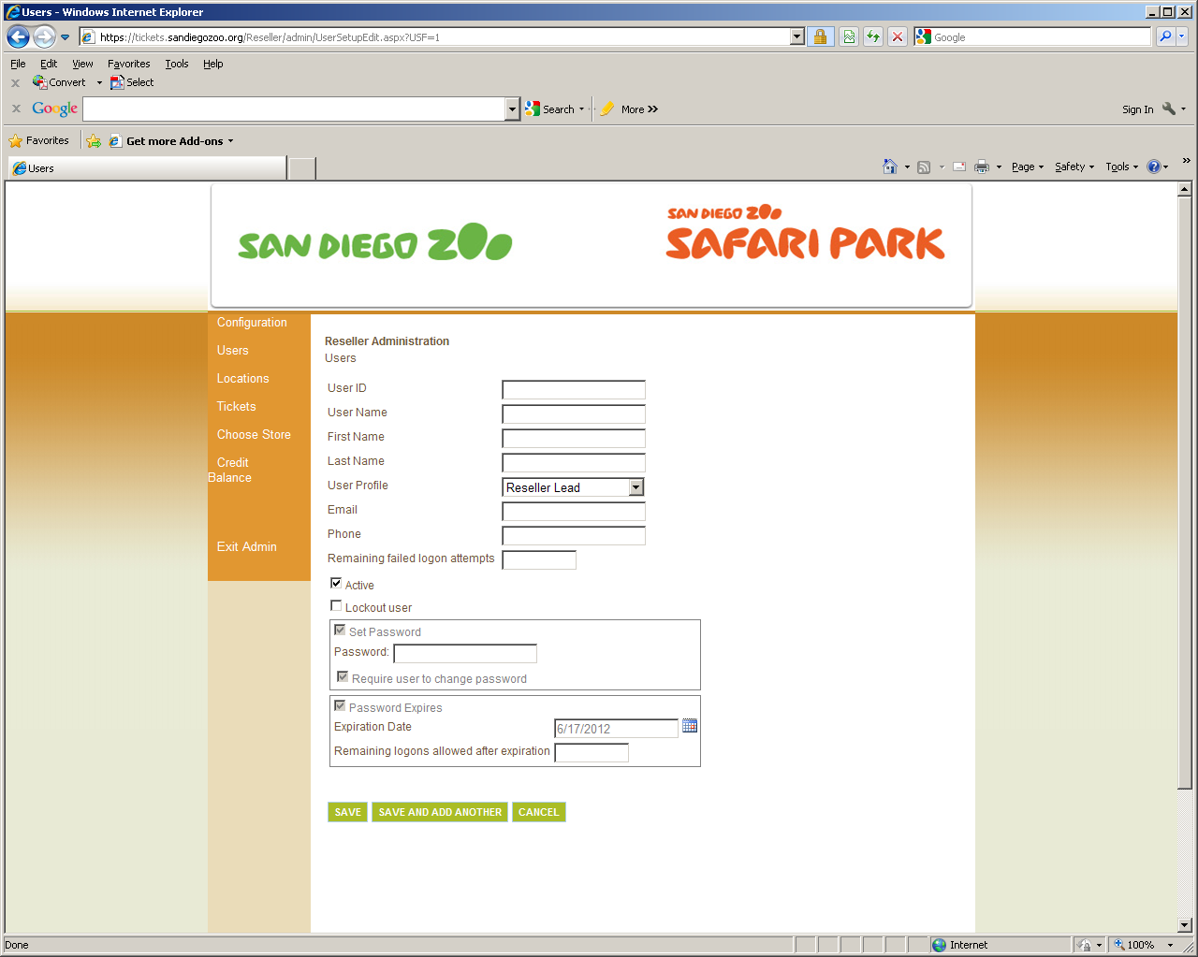
When creating a User, please use the following protocol:
Example: New User Name – Joe Smith
- User ID: User ID is auto created by the database sequentially
- User Name: 1st Initial of the User’s first name followed by the User’s full last name
  - JSmith
Note: If Galaxy responds that this user is already in the system, please use include the User’s middle initial – JLSmith
- First Name: Full First Name
- Last Name: Full Last Name
- User Profile: assign applicable profile for this user
- E-mail: E-mail address for user (if available)
- Phone: Phone number for user (if available)
- Password: JS123456 (1st initial of 1st name, 1st initial of last name followed by 123456) User will be prompted to change password on 1st login
All additional areas will automatically be updated when the new User is saved.
If you are creating multiple Users, click Save and Add Another. If creating only one User, click Save.
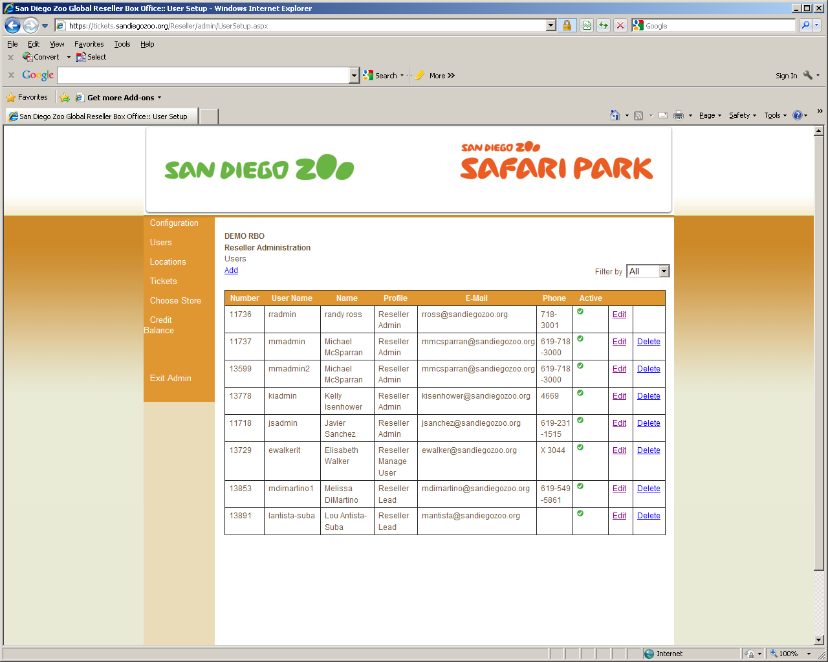

New User(s) will be reflected. Use the Edit option to make changes.
Lockout / Unlock Users
You may lock out a user from logging into Reseller Box Office. This option is preferred over deleting users as it will allow for accurate reporting of tickets sold. You may wish to lockout Users when they have left the company, are on an extended leave or you wish to review information with them prior to their next ticket sale.
To lockout a user:
- Locate User
- Click Edit
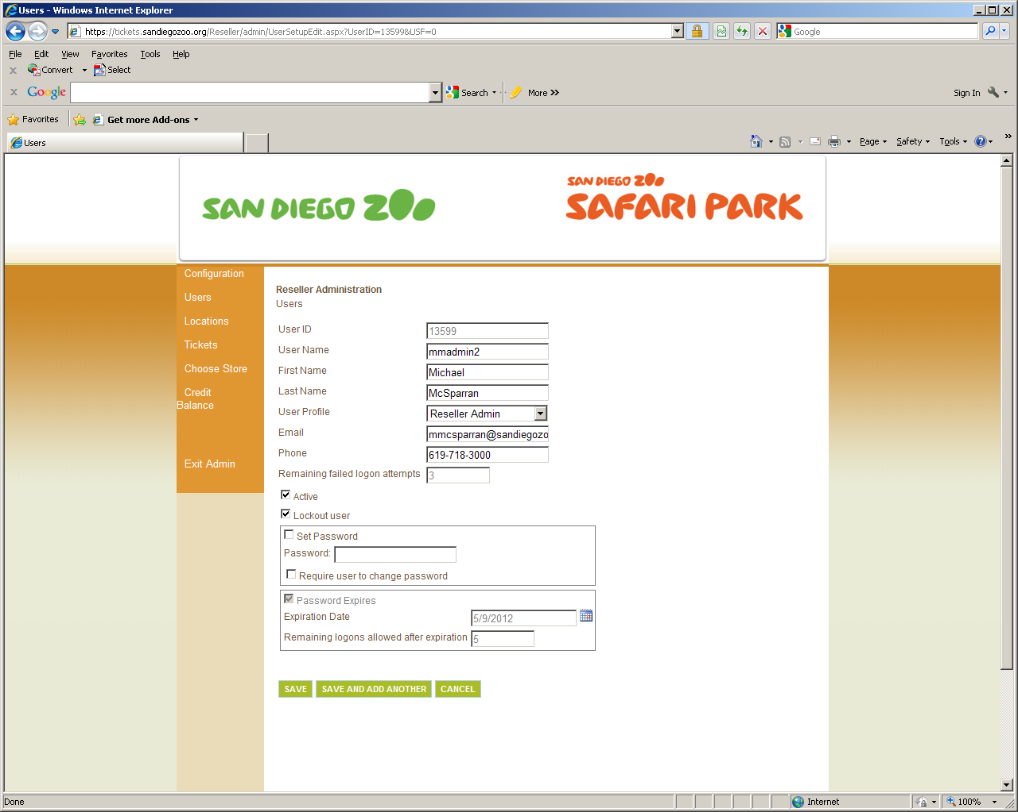

- Check box Lockout User (Uncheck box if you wish to Unlock a User)
- Click Save
NOTE: There are situations where the “Require user to change password box” is checked and even if the check is removed, the system will update it. In these cases, the user must change their password.

Ticket Configuration
Reseller Box Office allows the Reseller Lead to establish the price the ticket will be sold to the guest. The price can be set anywhere between the Minimum Retail Price (your contracted rate) and the Maximum Retail Price (the main gate price).
To set your rates in the system:
- Click Tickets

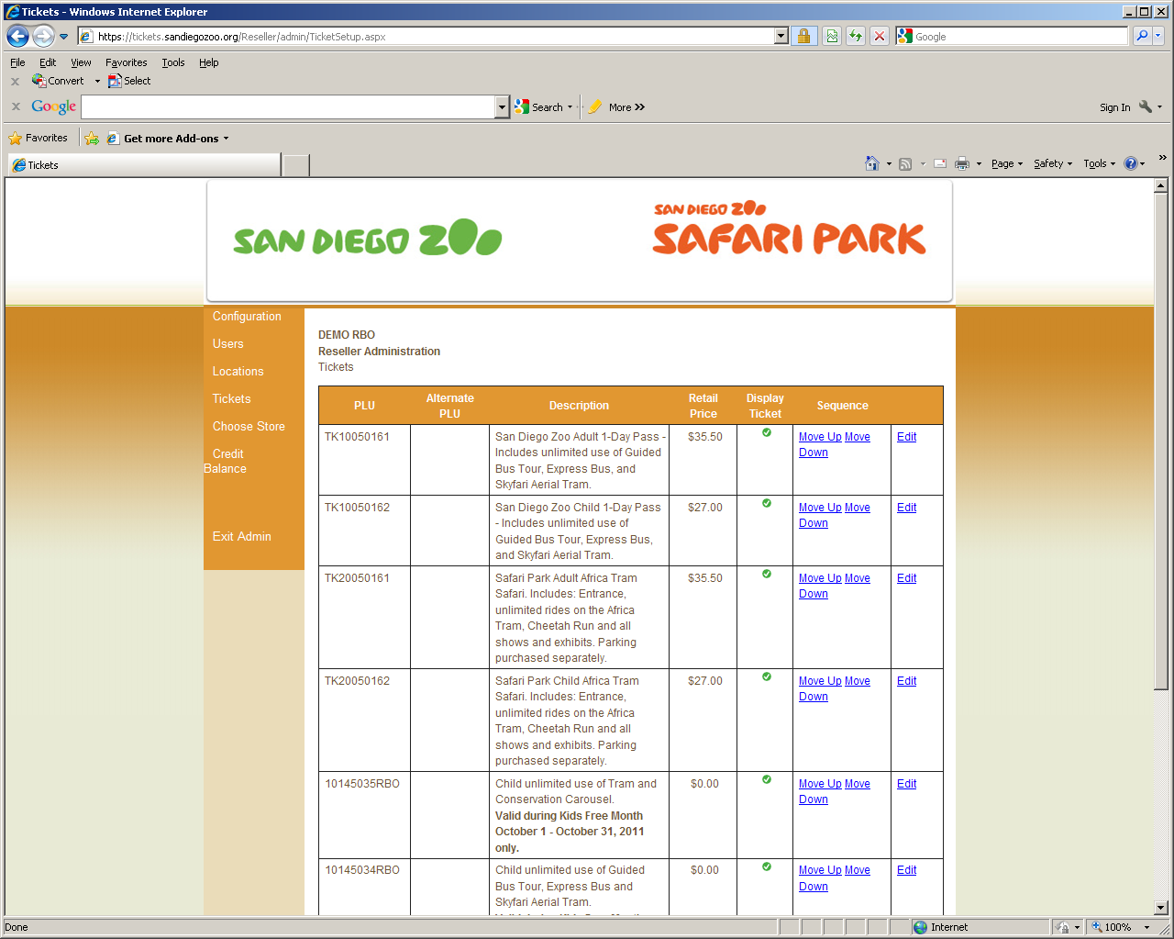
Each ticket you sell will be displayed. The retail rate shown is the rate currently configured.
- Click Edit

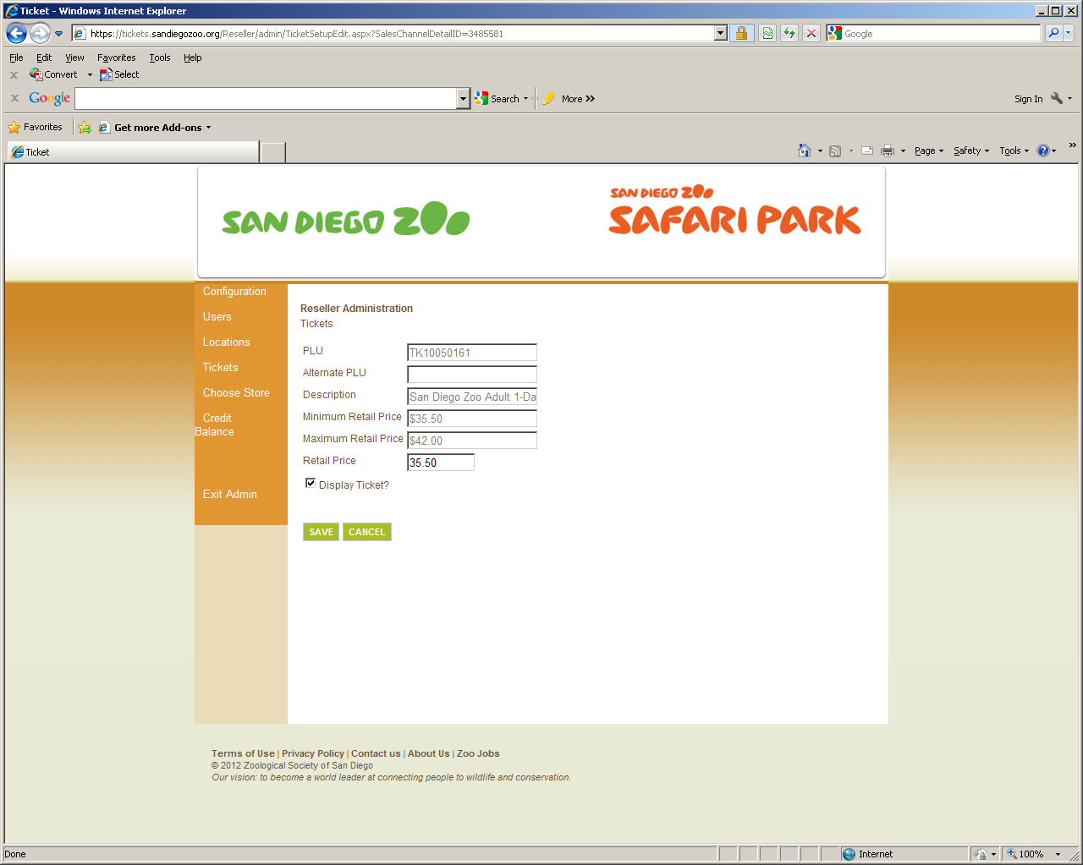
The Ticket Configuration page allows you to set the price you wish to sell the ticket.
- PLU: This is the San Diego Zoo PLU number (or SKU number)
- Alternate PLU: Enter your own PLU/SKU number for tracking (if applicable)
- Description: Brief description of the ticket
- Minimum Retail Price: Contracted purchase price
- Maximum Retail Price: The maximum allowed price
- Retail Price: Enter the price you wish to sell the ticket
- Display Ticket: Check box to display the ticket. Un-check box for ticket to not display
Click Save

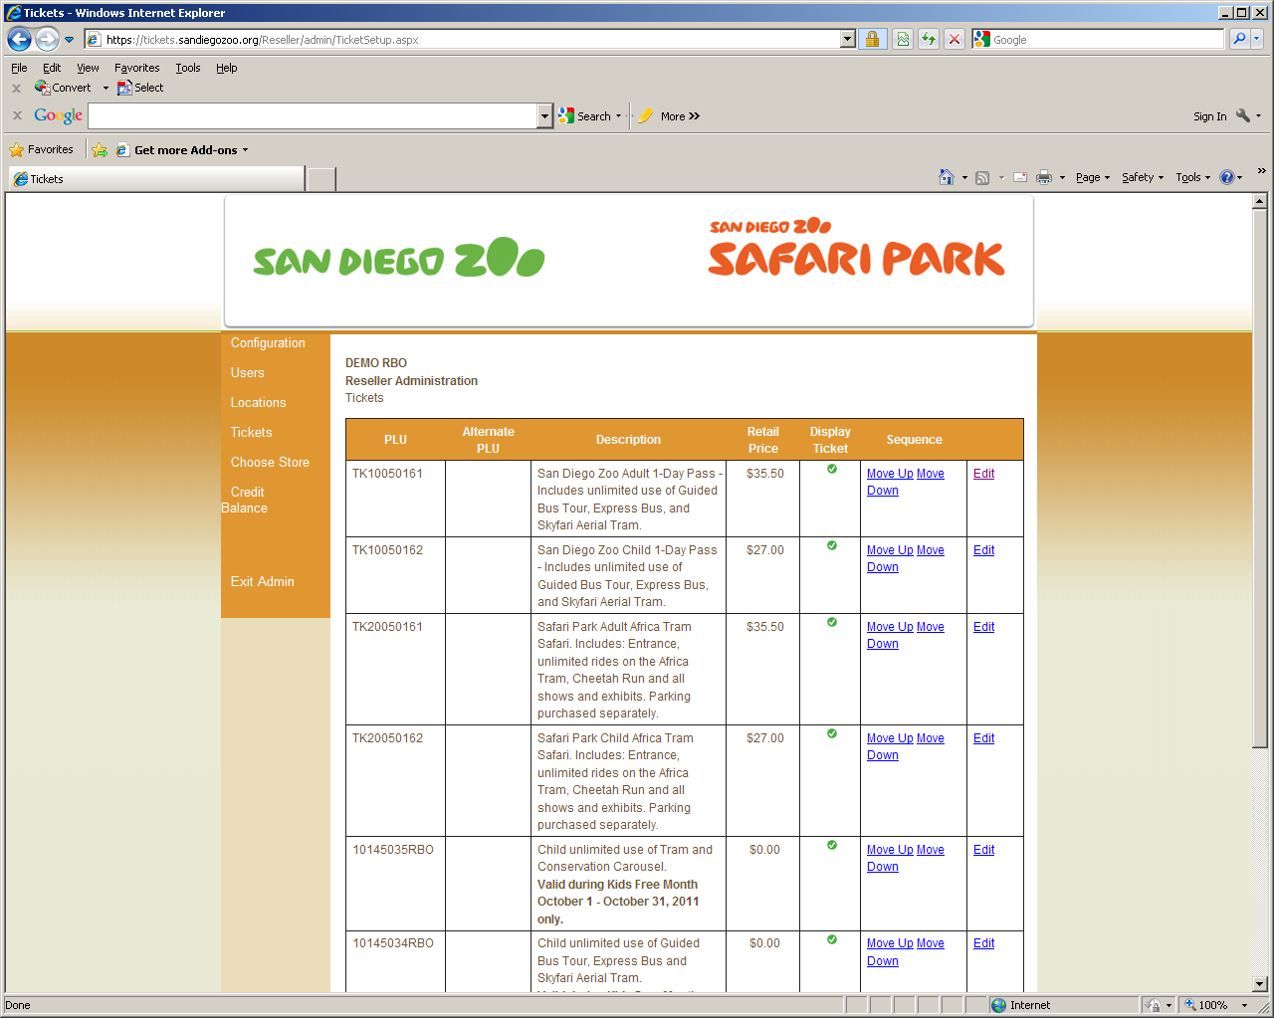
Example: The San Diego Zoo Adult 1-Day ticket has been updated to show a price of $35.50
Follow above steps for each ticket type. Rate changes will automatically take effect per your contract for the Minimum and Maximum Retail Rate. If you wish to adjust your own Retail rate when these changes take effect, please follow the steps above.
Log Off
Click Logout any time you are finished with using Reseller Box Office. The system will automatically log a User off after 20 minutes of inactivity
Selling Tickets
When your resellers work with tickets on the Reseller Box Office, they can sell and print tickets at their stores, as well as process returns.

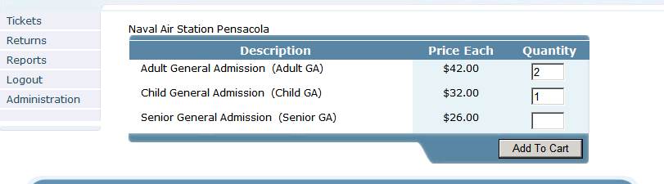
NOTE: It is highly recommended to not issue more than 25 total tickets at a time
To sell tickets on the Reseller Box Office:
On the Tickets page in the Quantity field, type the number of tickets to add to the order, then select Add To Cart. The Review page opens.
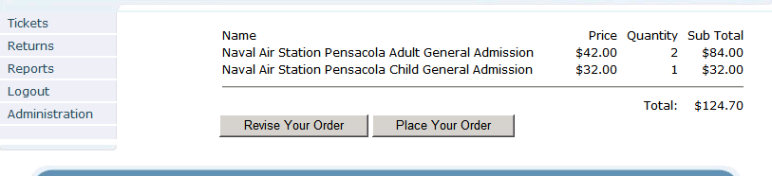
On the Review page, do one of the following:
- To make changes to the order, select Revise Your Order. The Tickets page reopens for your changes.
or
- To accept and place the order, select Place Your Order. The Confirmation page opens.
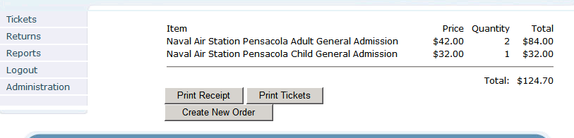

On the Confirmation page, do one or more of the following:
- To print a receipt, select Print Receipt.
- To print the tickets, select Print Tickets.
- To create a new order, select Create New Order. The tickets page reopens.
Returning Tickets
When you return a ticket on the Reseller Box Office, you must supply the Visual I.D. / Barcode for the ticket.

To return a ticket:
On the Tickets page in the Visual ID field,
- Type the visual ID for the ticket.
- Click Add (you will see the ticket number added and it will tell you if the ticket is valid or not. Only tickets showing a valid status can be returned)
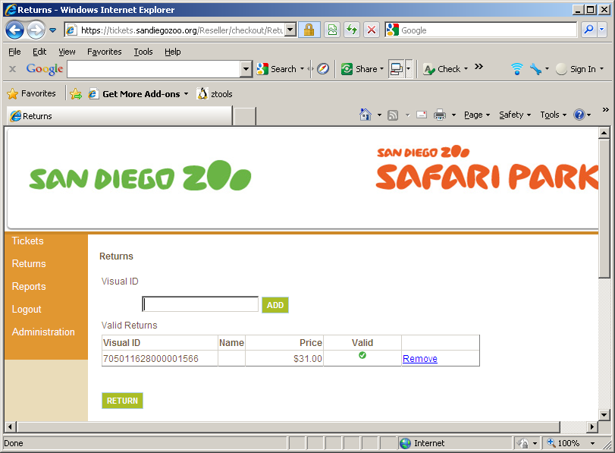
- Click Return
A return receipt will generate. (Note: Receipt is not designed for customer use but for internal reconcile documentation).
Prepaid accounts will show the value of the returned ticket immediately by checking the Prepayment Balance.

Logging Off of the Reseller Box Office
When you select Logout from any page on the Reseller Box Office, the system ends the session and displays the Login page.
To log off the Reseller Box Office:
- From the navigation area, select Log Out.

Reports

You can run reports based on your user privileges for the agencies or categories assigned to you.

The following reseller reports are available:
- Reseller Sales Summary - contains sales information for both tickets sold and returned. This report can be run for one or many ticket sellers, locations or resellers. The report displays item quantities sold, monetary sales and transaction quantities.
- Reseller Sales Detail - contains the individual transactions for the locations specified.
- Reseller Return Detail - contains information for tickets returned for the locations specified. The report displays retail, reseller and Galaxy prices in transaction number order.

Configuring Reports

When you configure report filters for Reseller reports, you configure the following:

- Report – Select the desired report type
- Start Date – Select the desired starting date and time for the report
- End Date – Select the desired end date and time for the report
- Category Group – Select desired Category Group if you have multiple types of accounts
- Category – Select desired Category
- Location – Select desired Location
- PLU – Select PLU if you wish to run a report for only one type of ticket
- User – Select User if you wish to run a report for a specific user only
- Format – Select PDF

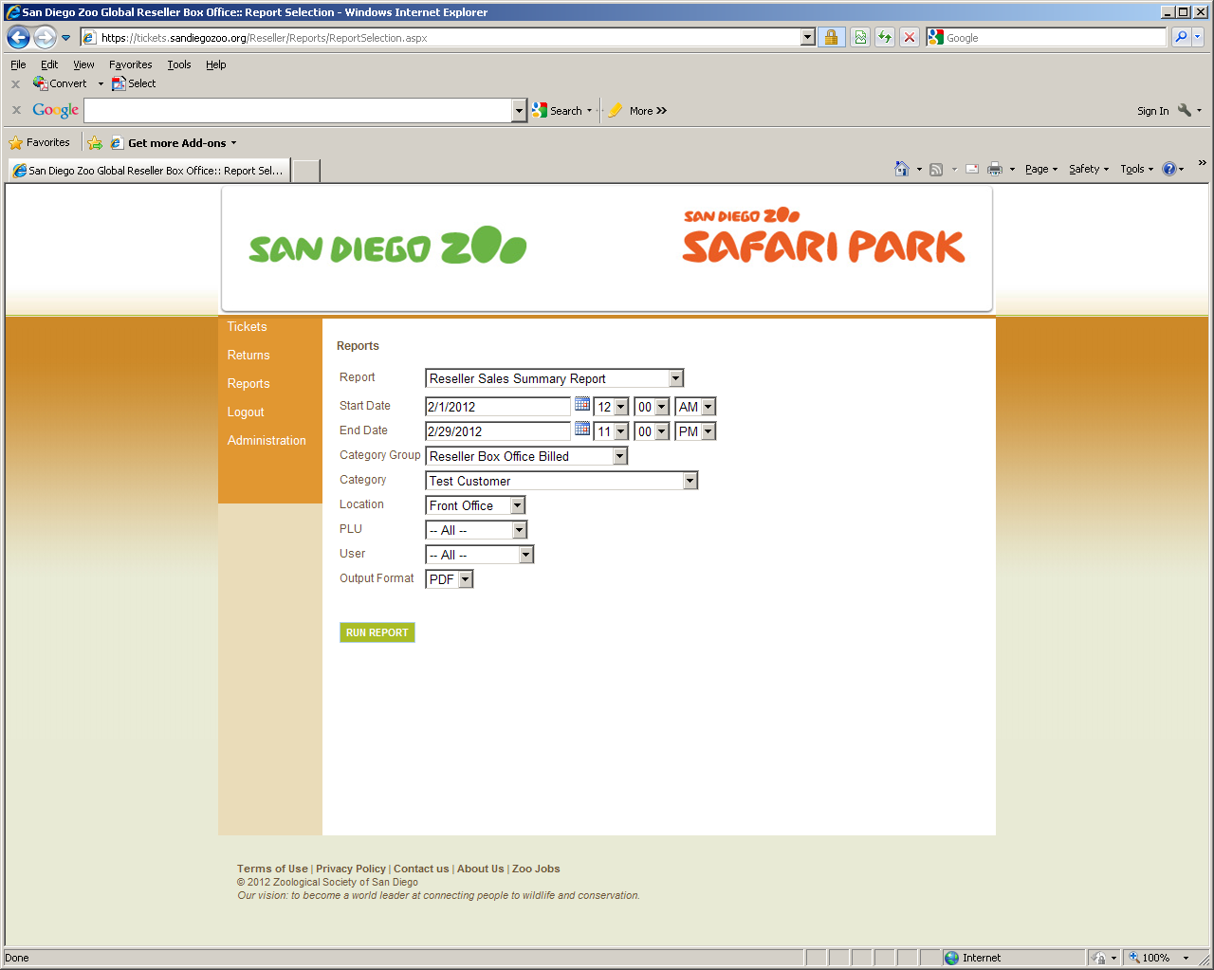
- Click Run Report

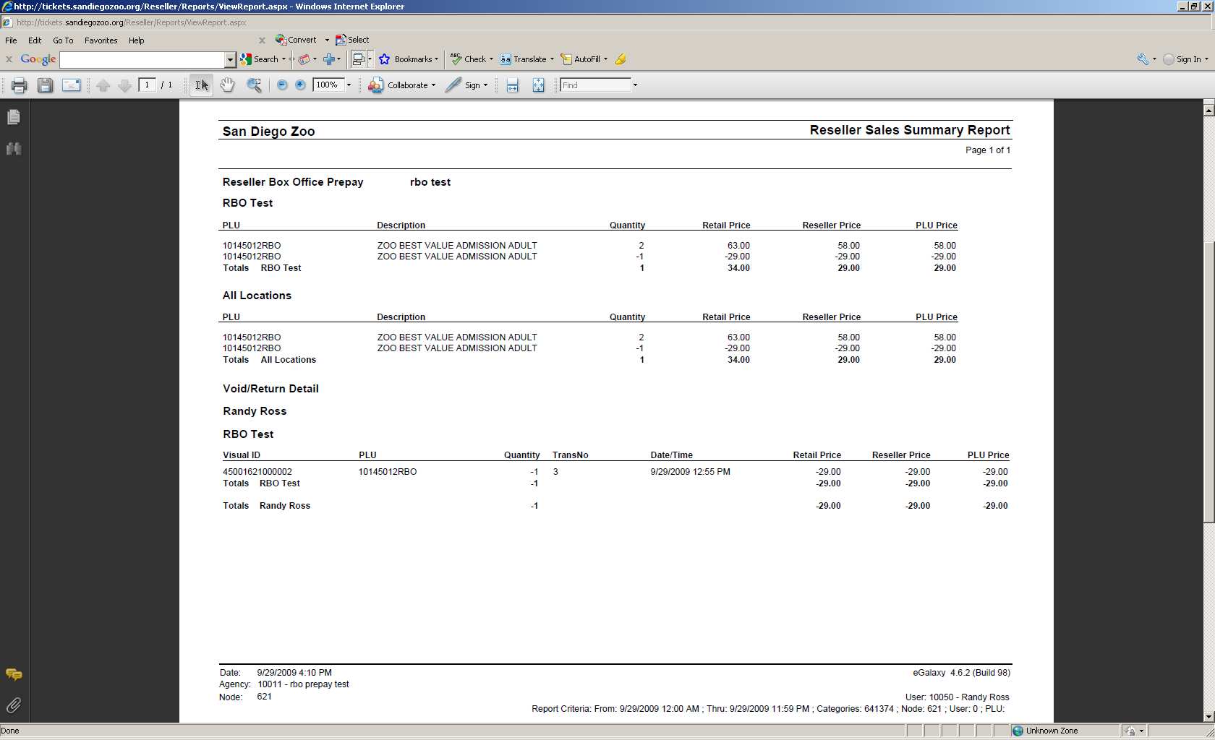
Understanding the Reseller Sales Summary Report
The Reseller Sales Summary report displays report information grouped by the following:
- Category Group
- Category
- Location
- User
The Reseller Sales Summary report provides the following information about sales transactions:
- PLU – Sales information by PLU
- Description – The PLU description
- Quantity – The quantity of tickets
- Retail Price – The retail price the ticket is sold to the guest
- Reseller Price – The contracted price the ticket is sold to the reseller
- PLU Price – The contracted base price of the ticket

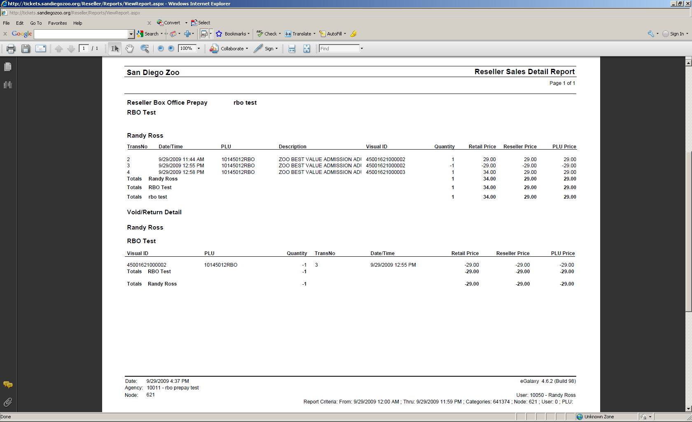
Understanding the Reseller Sales Detail Report
The Reseller Sales Detail report displays report information grouped by the following:
- Category Group
- Category
- Location
- User
The Reseller Sales Detail report provides the following information about sales information:
- Trans No – The transaction number recorded for the ticket purchase
- Date/Time – The date and time for the ticket sale
- PLU – The PLU for the ticket
- Description – The PLU description

- Visual ID – The Visual ID (ticket number) for the ticket
- Quantity – Quantity of tickets sold
- Retail Price – The retail price the ticket is sold to the guest
- Reseller Price – The contracted price the ticket is sold to the reseller
- PLU Price – The contracted base price of the ticket

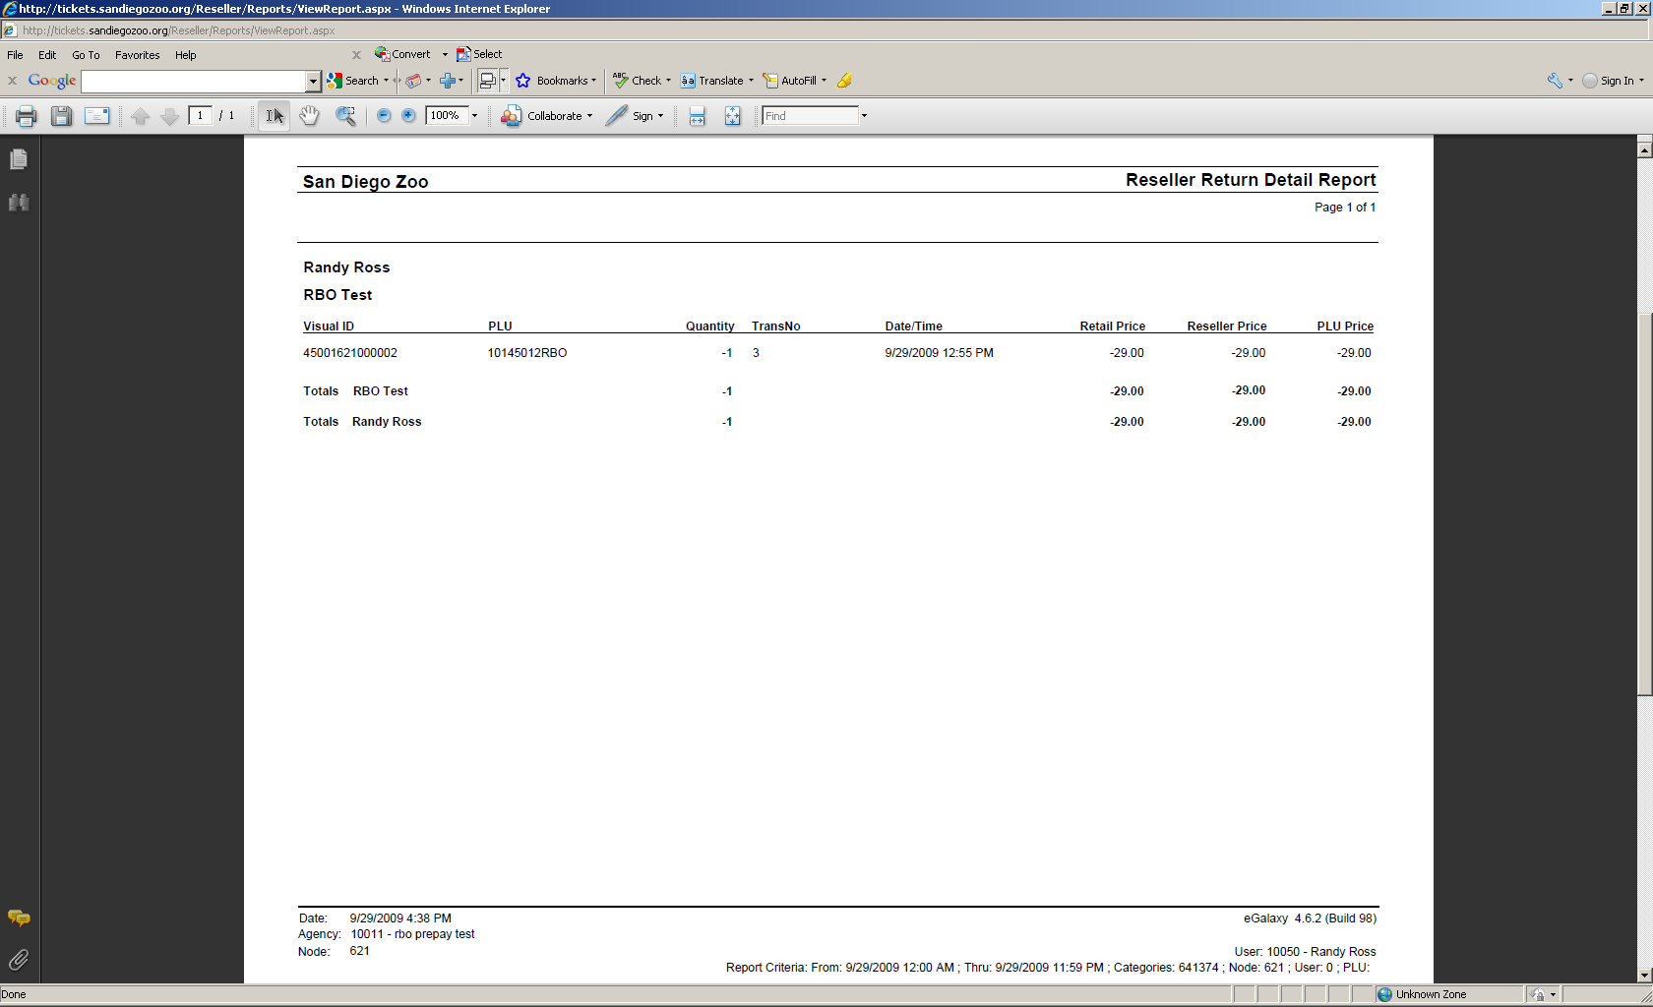
Understanding the Reseller Return Detail Report
The Reseller Return Detail report displays report information grouped by the following:
- Category Group
- Category
- Location
- User
The Reseller Return Detail report provides the following information about ticket returns:

- Visual ID – The Visual ID (ticket number) for the ticket
- PLU – The PLU for the ticket
- Quantity – Quantity of tickets sold
- Trans No – The transaction number recorded for the ticket purchase
- Date/Time – The date and time for the ticket sale
- Retail Price – The retail price the ticket is sold to the guest
- Reseller Price – The contracted price the ticket is sold to the reseller
- PLU Price – The contracted base price of the ticket
Return Detail:
- Visual ID – The Visual ID (ticket number) for the ticket returned
- PLU – The PLU for the ticket returned
- Quantity – Quantity of tickets returned
- Trans No – The transaction number recorded for the ticket purchase which was then returned
- Date/Time – The date and time for the ticket return
- Retail Price – The retail price the ticket is sold to the guest that was returned
- Reseller Price – The contracted price the ticket is sold to the reseller that was returned
- PLU Price – The contracted base price of the ticket that was returned

PRE-PAID Accounts ONLY
Checking your Balance
RBO balances can be checked under the administrative functions
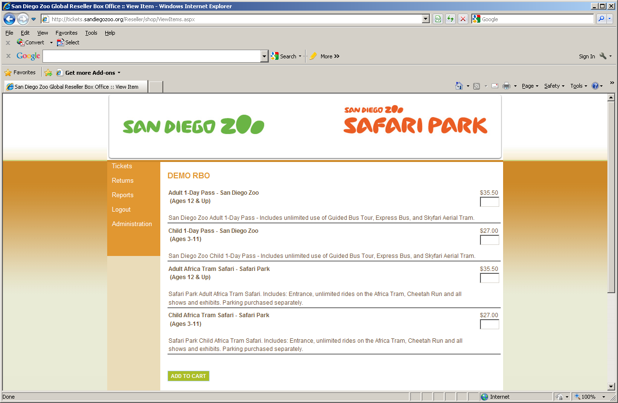
- Click Administration

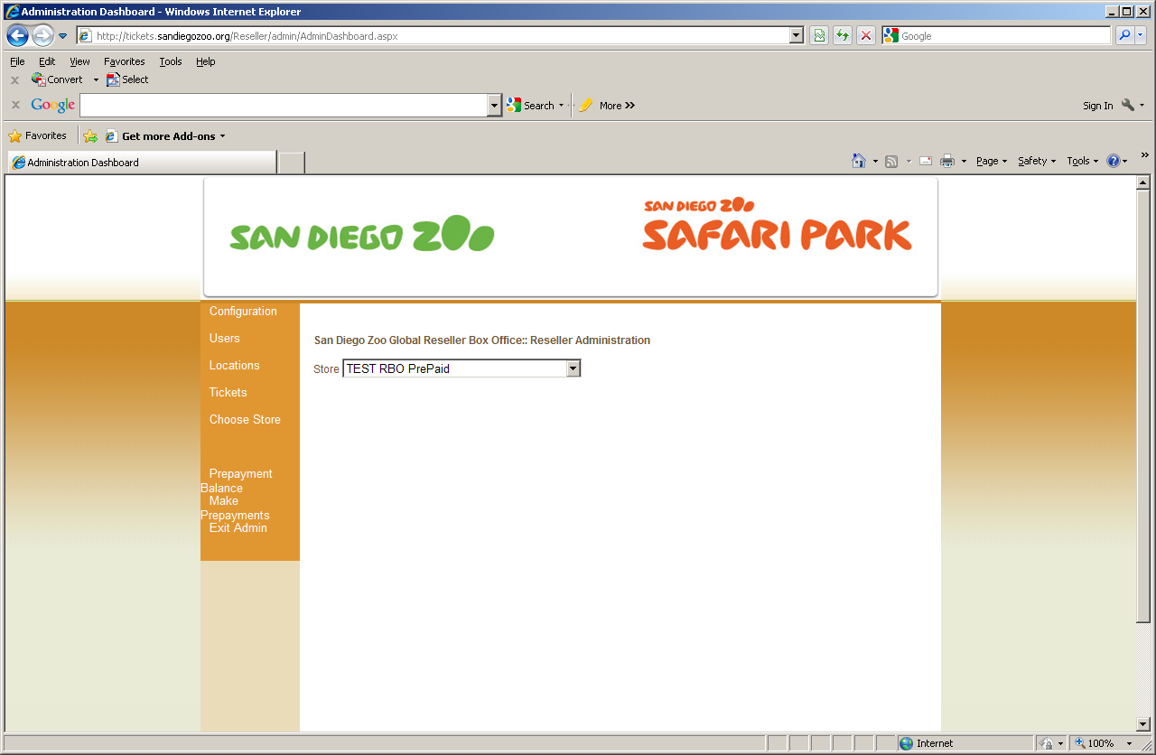
- Click “Prepayment Balance”

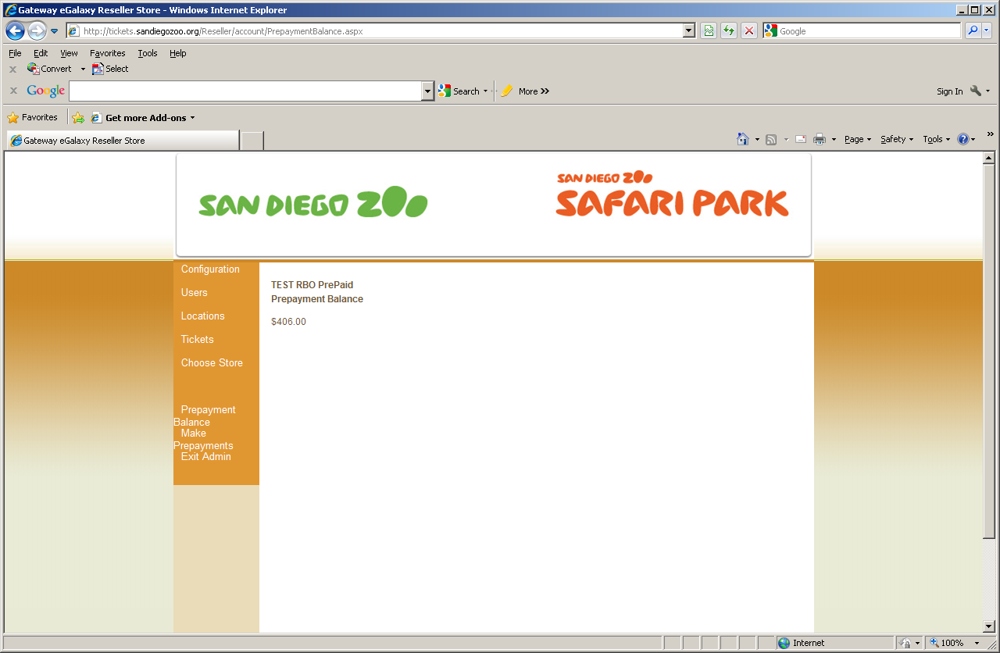
- Balance is displayed
Note: Balances are real time

Making a payment on a Pre-Paid account
RBO payments can be made under the administrative functions

- Click Make Prepayments

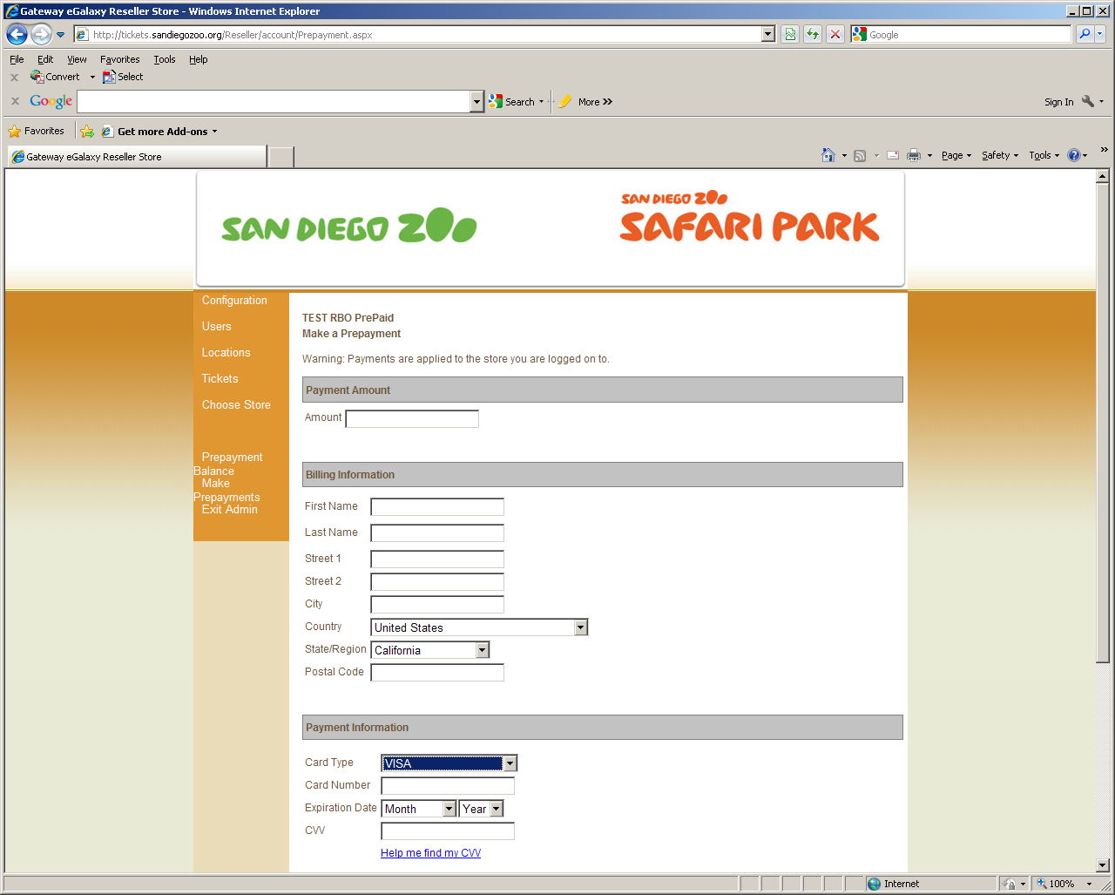
Enter:
- Amount you wish to add to account
- Credit Card Holder Name
- Billing address of Card
- Type of Credit Card
- Credit Card Number
- Credit Card Expiration Date
- CVV #
NOTE: Please verify amount you are applying. Funds cannot be removed / refunded
Click “Apply Payment”
- Checking your balance again will display the updated balance

Internet Security

A new security feature has been added to our Reseller Box Office that will prevent your employees from logging into Reseller from outside your network. This is done by obtaining your IP Addresses or a range of your IP Addresses.

An example on how this works, when your employee logs on to the Reseller Box Office to purchase tickets, the store verifies that the IP address that is accessing the store is part of the approved range of IP addresses. Once the IP address is verified, the
employee can perform Web store transactions normally. If the IP address is not in the list of addresses, the employee receives a message informing them that they cannot access the Reseller Box Office because their IP address is not permitted to purchase tickets on the store.

If you have not already done so, please provide your Public IP Address or Addresses for the computers you will be accessing Reseller Box Office. If you are unfamiliar on how to obtain the Public IP Address, please contact your I.T. Department.

Sample Ticket – (scaled down for presentation purposes only. Normal tickets are 8.5”x11”



