Selling Tours in Reseller Box Office
Login to Reseller Box office
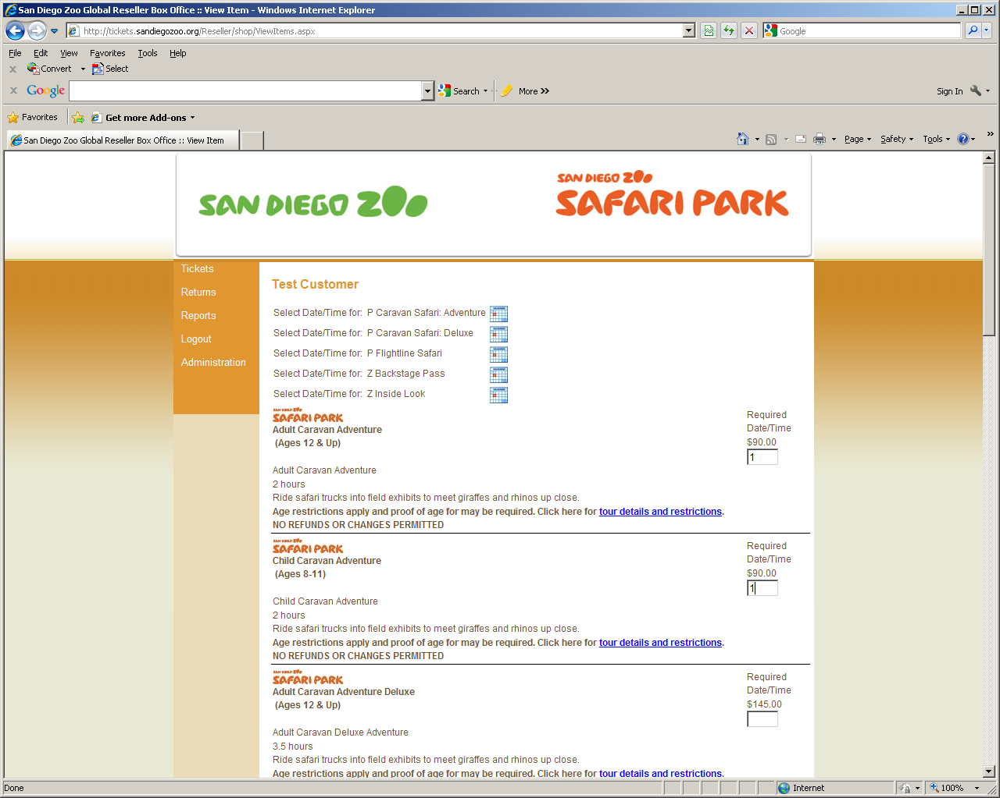

Enter the applicable number of Adults and Children for the desired tour (Green Arrow)
Click on the applicable event calendar (Red Arrow)
Note: By entering the number in the party first, only the events with the available capacity for the size of your group will be provided
For up to date tour details and restriction, please use hyperlinks located in the description for each tour (Blue arrow)

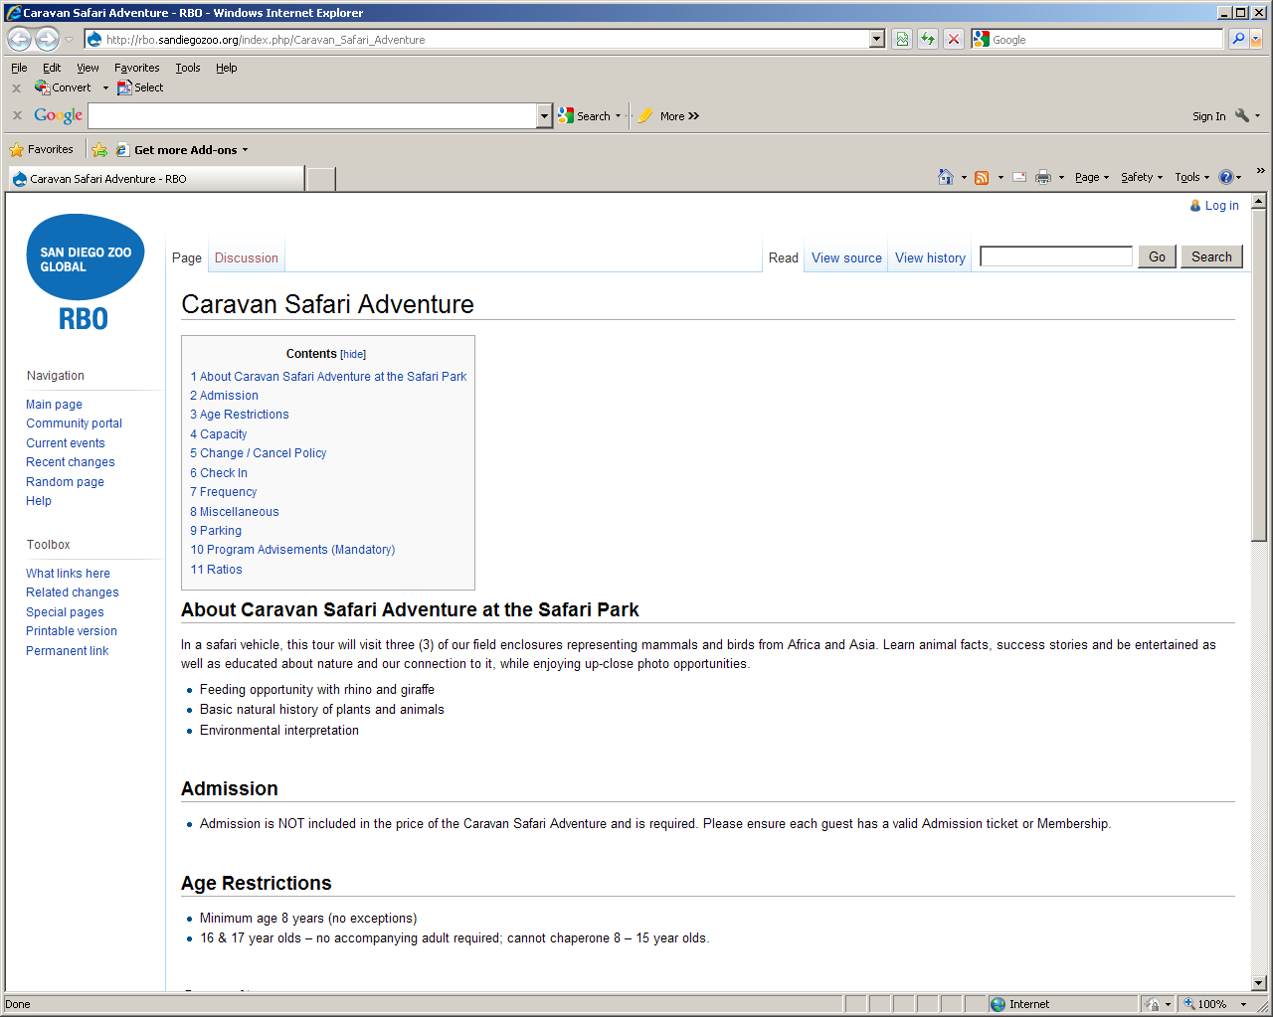
Please review tour details and restrictions
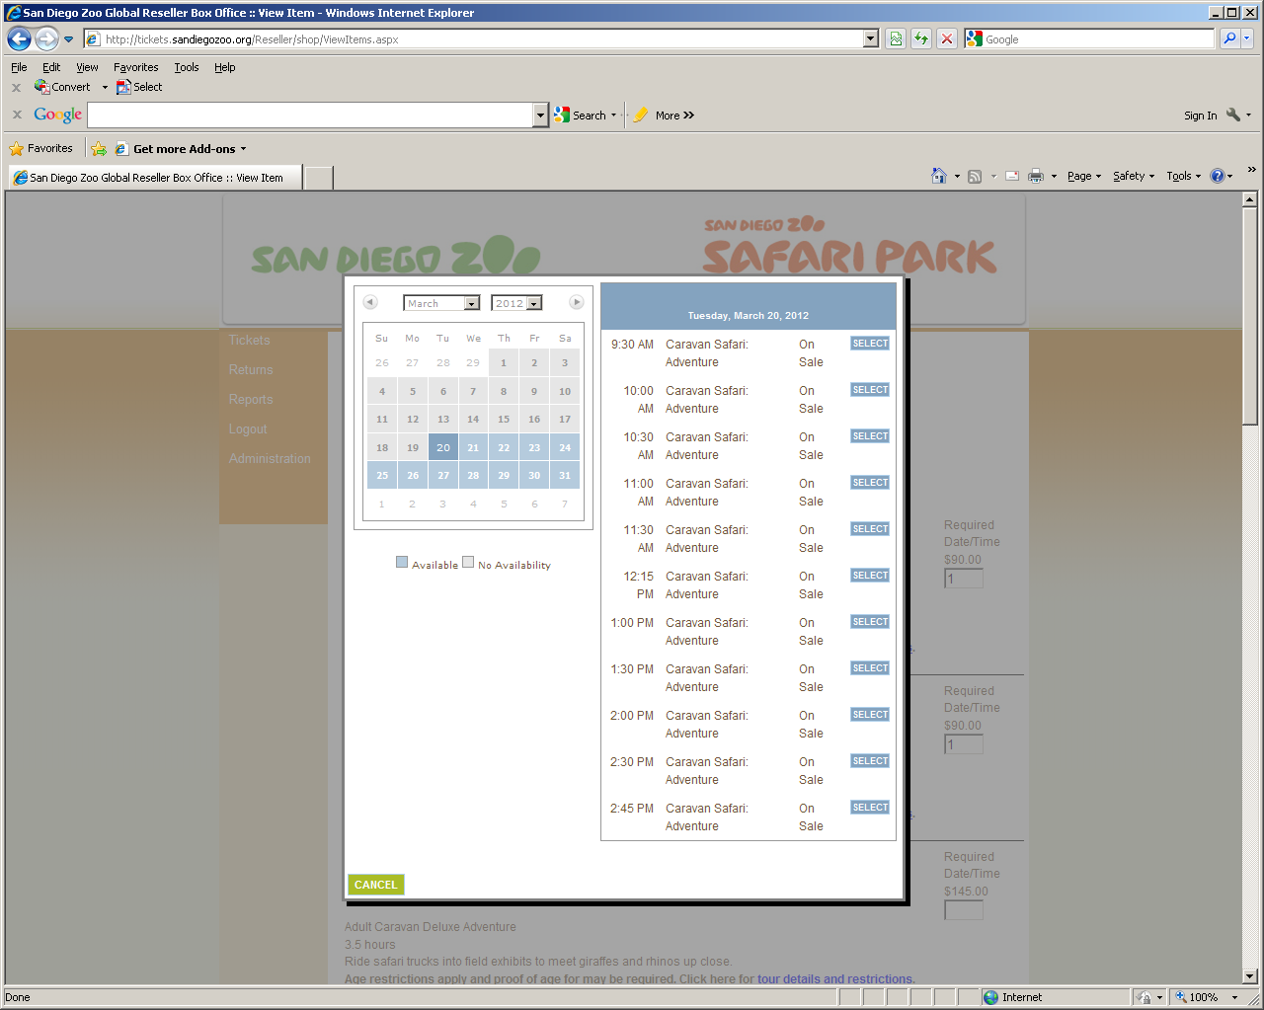
The calendar defaults to the first available tour. If tours are not available today, the next applicable date and time will be displayed. Calendar dates highlighted in blue have available tour dates. The calendar will only show availability one month at a time.
Choose the desired date of the tour. For this example, we are picking March 31
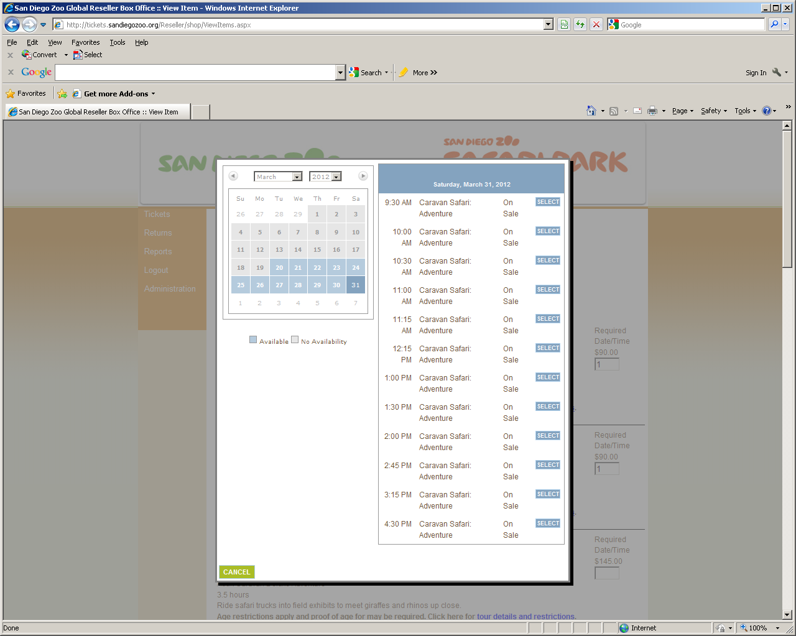
Verify the date chosen on the calendar matches the dates for the available tours
Click the “Select” button for the desired time
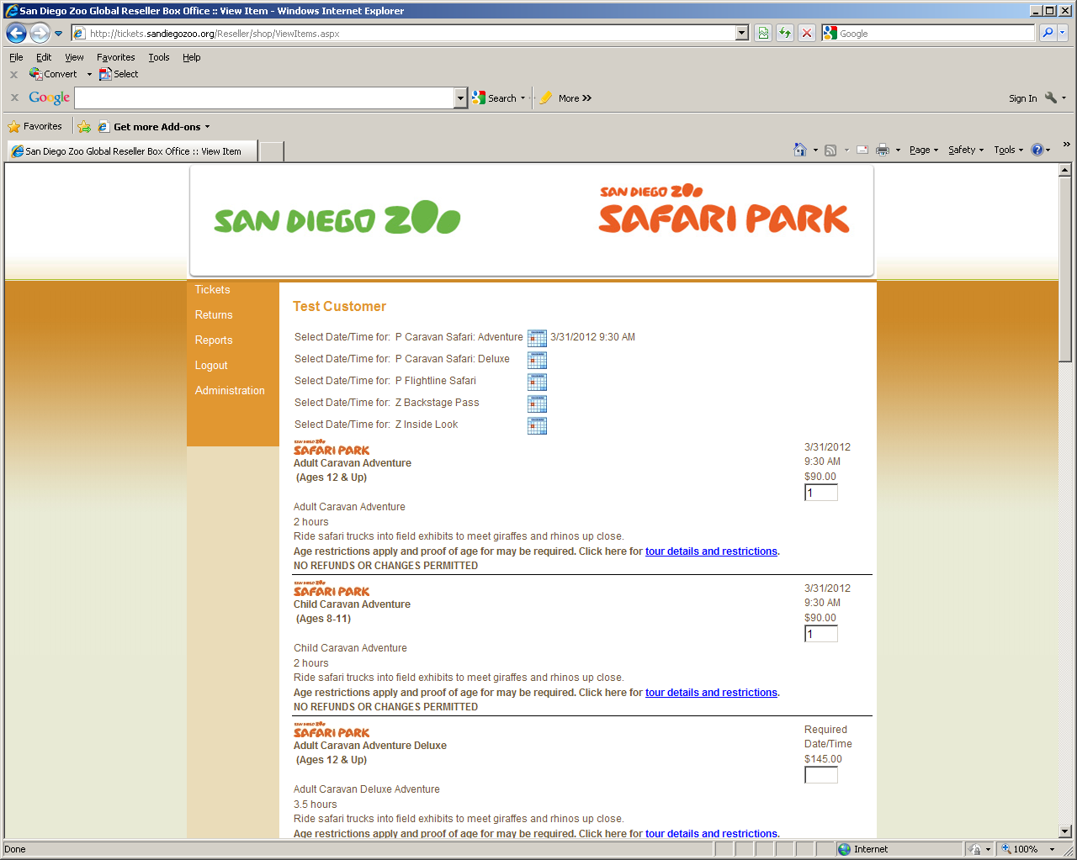
Verify the date and time for each PLU match the desired time chosen
If you need to change the date or time, click on the calendar icon again and repeat the process
Repeat process for any additional tours
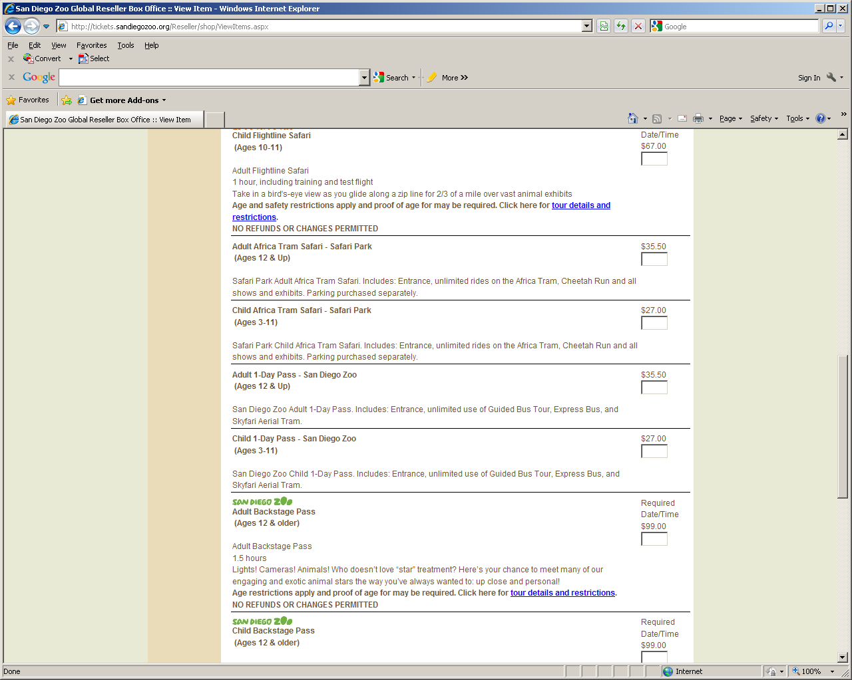
Select applicable admission tickets
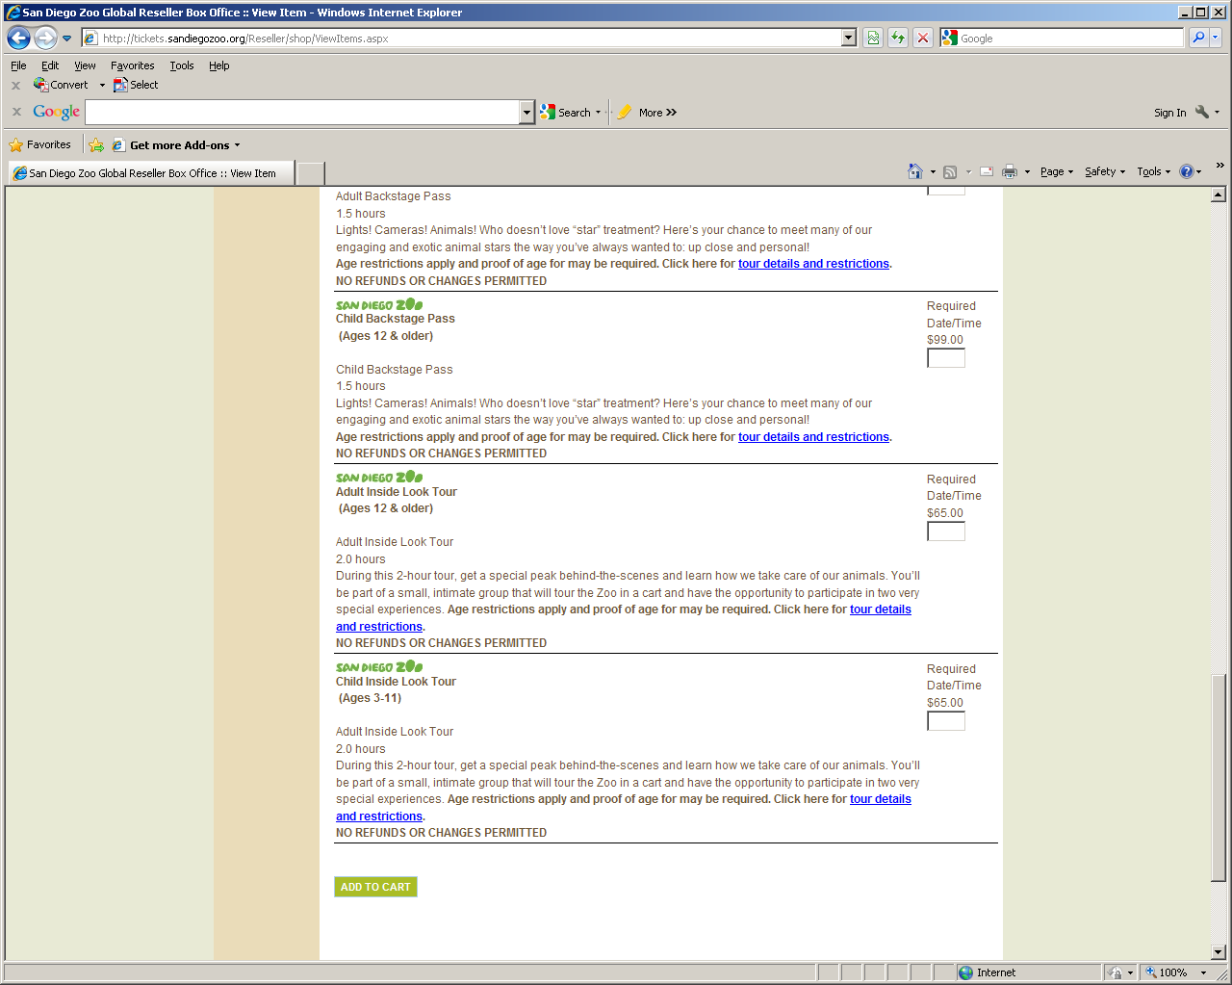
Scroll to the bottom of the screen and click “Add to Cart”

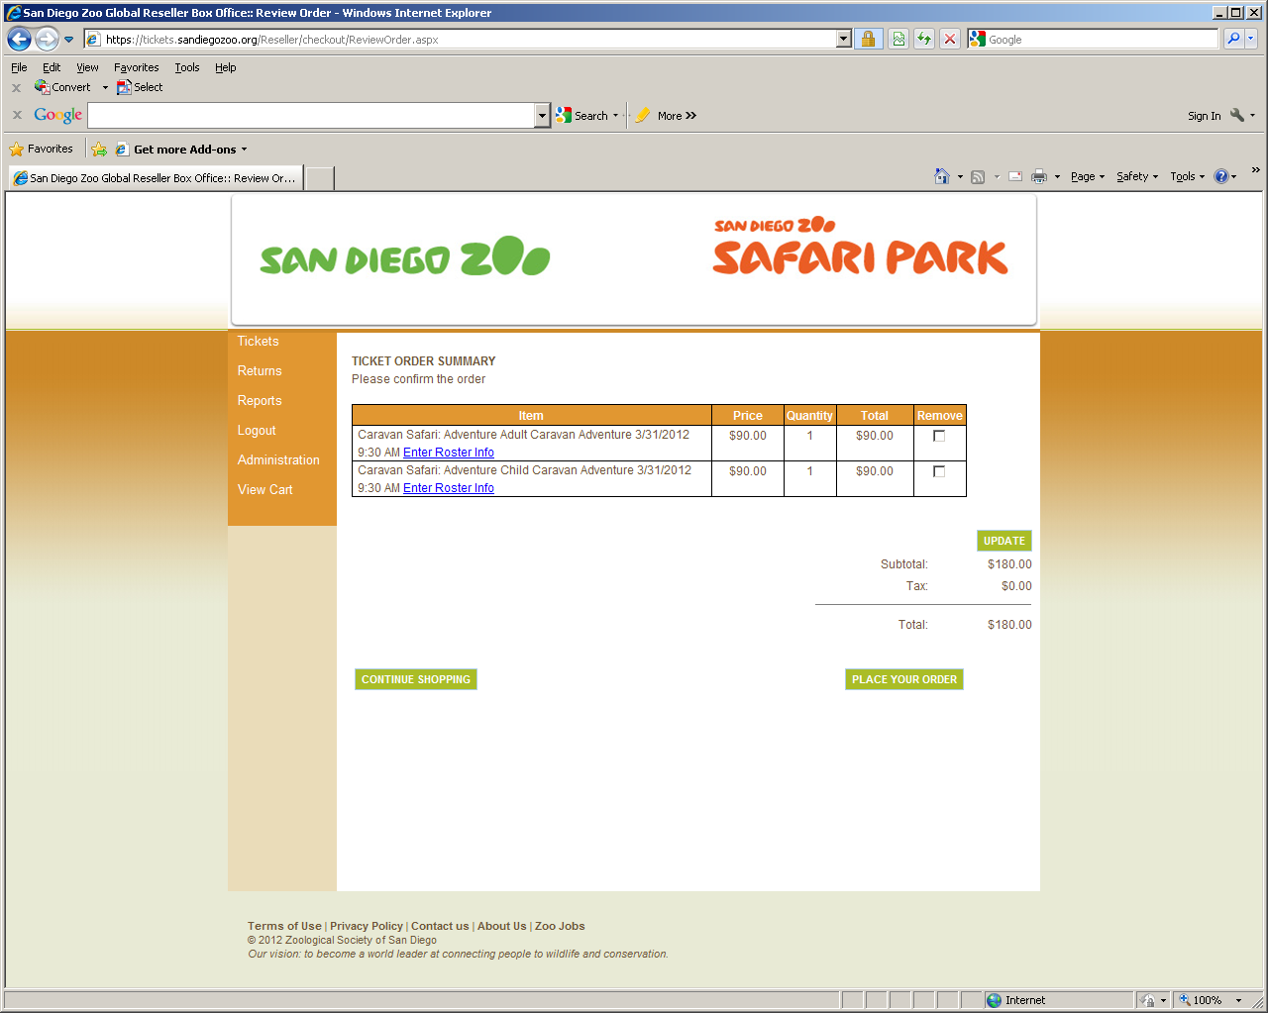
Click “Enter Roster Info”

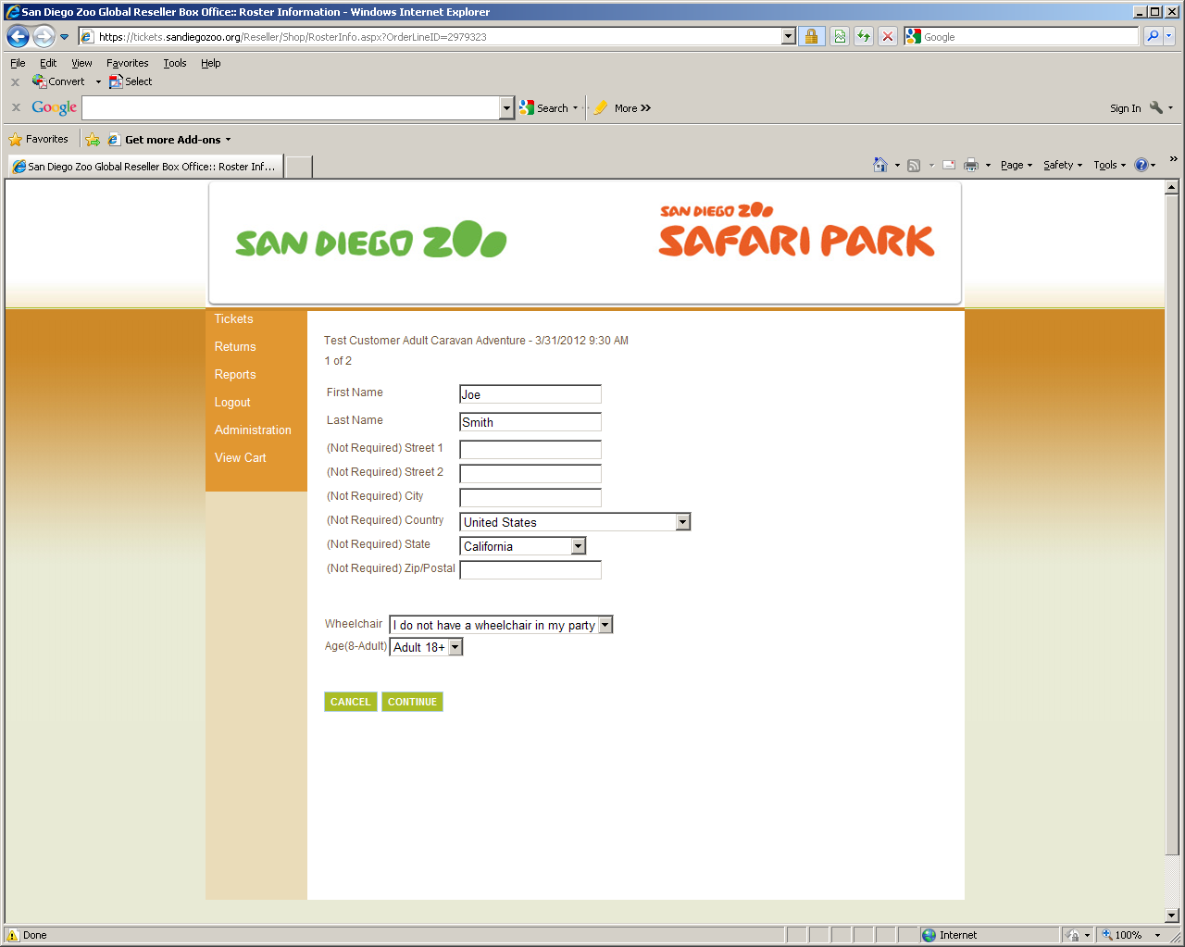
Enter first & last name of the guest along with ADA, age and other required attributes
Note: Incorrectly entering ADA, Age or other required attributes could deny the guest from attending the tour. NO REFUNDS will be allowed.

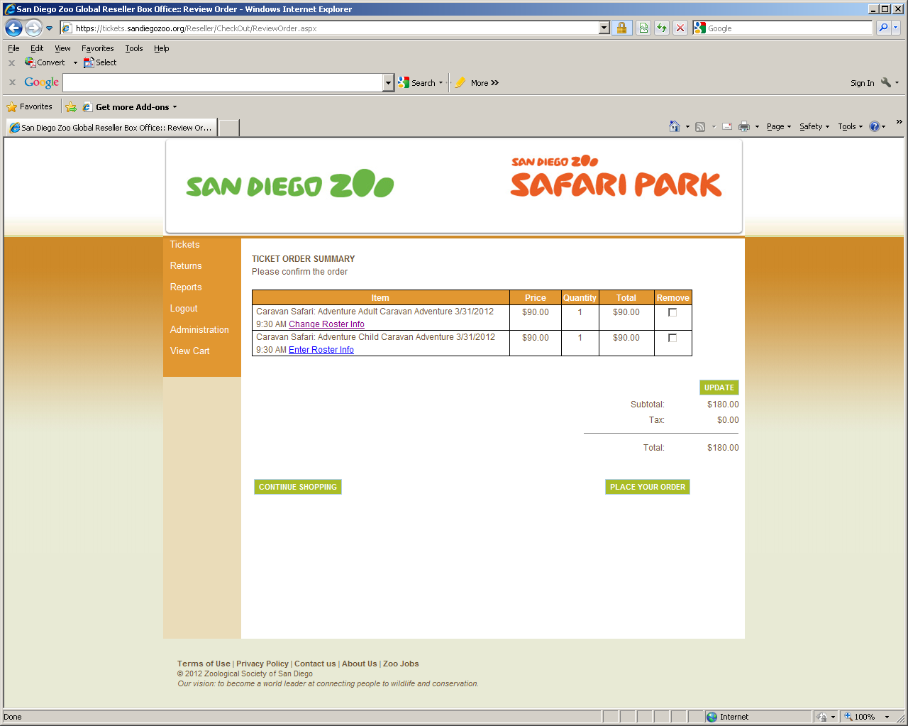
Complete all Rosters for each guest on each tour
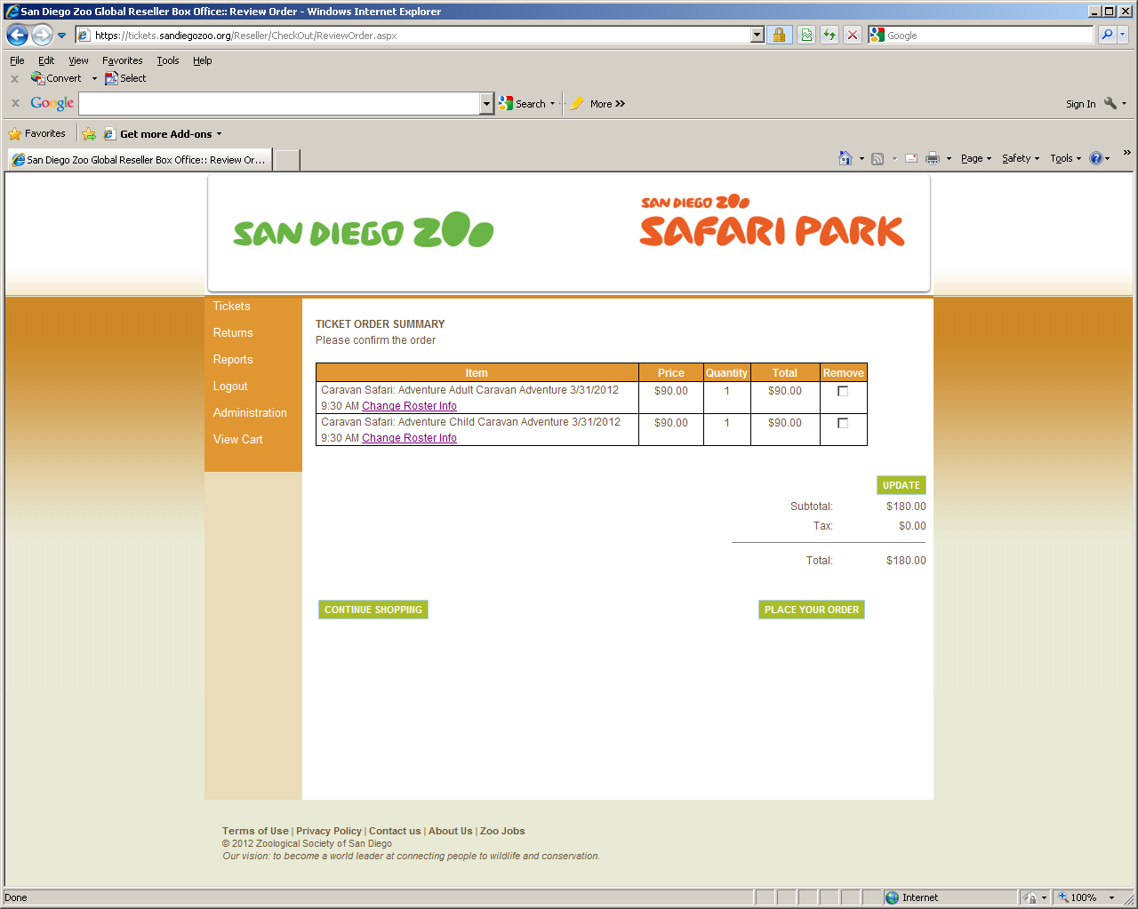
Verify date and time
Click “Place your order”
Please print the PDF ticket that generates and provide to your guest. They will need to present it at the time of their tour.

